PROJECT REPORT
ON
BLOOD BANK

Submitted to PANJAB UNIVERSITY, CHANDIGARH

in fulfillment of the requirements for the degree of

MASTER OF SCIENCE IN INFORMATION TECHNOLOGY

(M.Sc. (IT) 4th Semester)

By
Navdeep Kaur
Ashu Gaba

Department Of Computer Science
GURU NANK GIRLS COLLEGE
MODEL TOWN, LUDHIANA
SESSION: 2015-2016

PROJECT REPORT
ON
BLOOD BANK

Submitted to PANJAB UNIVERSITY, CHANDIGARH
in fulfillment of the requirements for the degree of
MASTER OF SCIENCE IN INFORMATION TECHNOLOGY

(M.Sc. (IT) 4thSemester)

Project Guides Submitted By:
External Guide Navdeep Kaur
Ms. Prabhleen Kaur Roll no:
Internal Guide Ashu Gaba
Mrs. Ramanpreet Kaur Roll no:

Department Of Computer Science
GURU NANK GIRLS COLLEGE
MODEL TOWN, LUDHIANA
SESSION: 2015-2016

ACKNOWLEDGEMENT

The success and final outcome of this project required a lot of guidance. First and foremost, we would like to thank God for giving us courage to bring up this project. At the outset, we would like to propose a word of thanks to our worthy Principal, Dr. (Mrs.) Charanjit Mahal for providing us the facilities and encouraging us at every moment.

We would also like to express a deep sense of gratitude and thanks profusely to Mr. Ashish Jalota and Mr. Ansh Aneja Director/CEO of company. Without his wise counseling and able guidance it would have been impossible to complete the project in this manner. The help rendered by Ms. Prabhleen Kaur for experimentation is greatly acknowledged.

We would also like to express our special thanks of gratitude to our Project Guide, Mrs. Ramanpreet Kaur. Her enthusiasm was constant source of inspiration to us. Her willingness to motivate us contributed tremendously to our project.

Last but not the least, we wish to avail ourselves for this opportunity, express a sense of gratitude to our parents who helped us in finishing our project with their support, love and for everything.

Navdeep Kaur

Ashu Gaba

Date:

CERTIFICATE

This is to certify that the project entitled “BLOOD BANK” submitted to Panjab University, Chandigarh in fulfillment of the requirements for the degree of Masters of Science in Information Technology (M.Sc. (IT) 4th Semester) is a bonafide work carried out by Navdeep Kaur and Ashu Gaba under our supervision and no part of this work has been submitted for any other degree.
The assistance and help received during the course of work has been fully acknowledged.

External Guide

Ms. Prabhleen kaur

Internal Guide

Mrs. Ramanpreet Kaur

Principal

Dr. (Mrs.) Charanjit Mahal
Guru Nanak Girls College
Model Town, Ludhiana

STUDENT DECLARATION

We hereby declare that the project entitled “BLOOD BANK” submitted by Navdeep Kaur and Ashu Gaba in fulfillment of the requirements for the degree of Master of Science in Information Technology (M.Sc. (IT) 4thSemester, Session 2015-16) to Panjab University, Chandigarh is an original work and has not been submitted for the reward of any other degree/diploma/scholarship or any other similar title or prize.

Place: Ludhiana
Date:

Navdeep Kaur
Ashu Gaba

External Guide Internal Guide

Ms. Prabhleen Kaur Mrs. Ramanpreet Kaur

LIST OF CONTENTS
- Introduction to Company
- Introduction to Project
- Objective of Project
- System Analysis
- Feasibility study
- Hierarchy of Project
- Data Flow Diagram
- Hardware and software requirements
- Tools And Techniques
- Implementation
- Source code
- Screen Layouts of project
- Testing
- Future scope
- Bibliography
- Webliography

Introduction to Company
About the Company
ANSH InfoTech is an Information Technology & Product Base Company, in India. ANSH InfoTech is committed to Empowering Business Transformation. The company was founded with its core values focused on Creative, People Driven, Socially Conscious, Intense and Ethical. The company provides software products, IT services, for a variety of industries including insurance, banking, capital markets and retail markets. These products and services include managed IT services, application software development and maintenance, payment systems, business intelligence, web development, IT consulting and various transaction processing services. We undertake projects located around the world and are committed to creating a challenging and rewarding work environment whereby our team members are goal focused and motivated throughout our clients' engagement. Our goal is to provide the most cost effective solutions while keeping in mind the urgency to launch products without sacrificing the quality. Excellence lies at our heart, we constantly challenge the convention. Excellence, Partnership and Commitment are the three hallmarks with which we approach our clients, we believe and you will see this in our service. Company also has a Training division that offers learning management and training delivery solutions to Corporations, Institutions and Individuals. It is Global Leader in Skills & Talent Development having three main lines of business: Corporate Learning Group (CLG), Skills and Careers Group (SCG), and School Learning Group (SLG).
Services Offered by Company:
• Software Development
• Web Designing/Web Development
• Internet Marketing
• Application Development(iphone/android)
• Business Consultancy
• Job Consultancy
• Project & Research Training
• Robotics & Embedded System Development
• Home Automation
Introduction to Project
The Blood Bank portal is to create an e-Information about the donor and organization that are related to donating the blood. Through this application any person who is interested in donating the blood can register himself in the same way if any organization wants to register itself with this site that can also register. Moreover if any general consumer wants to make request blood online he can also take the help of this site. Admin is the main authority who can do addition, deletion, and modification if required.

This project is aimed to developing an online Blood Donation Information. The entire project has been developed keeping in view of the distributed client server computing technology, in mind.

The Blood Bank portal is to create an e-Information about the donor and organization that are related to donating the blood. Through this application any person who is interested in donating the blood can register himself in the same way if any organization wants to register itself with this site that can also register. Moreover if any general consumer wants to make request blood online he can also take the help of this site.
Admin is the main authority who can do addition, deletion, and modification if required.

The project has been planned to be having the view of distributed architecture, with centralized storage of the database. The application for the storage of the data has been planned. Using the constructs of Xampp Server and all the user interfaces have been designed using the PHP technologies.

The database connectivity is planned using the “MYSQL Connection” methodology. The standards of security and data protective mechanism have been given a big choice for proper usage.

Modules of Project

About Administrator Module
Admin: - Administrator can perform the following tasks on this site.
- He can manage events by adding new events which can be viewed on the main page, simultaneously deleting the events which have occurred.
- He can manage news’s by adding news’s which can be viewed on the main page.
- He has facility to view the registered members, ngo’s and donors who are ready to donate blood.
- He can add new banks which are ready to be a part of our web portal.

Ngo’s :–Ngo’s can perform the following task.
- Ngo’s can register to the portal and create their account for adding events to the portal.
- They can add and display events on their designed portal page which will be viewed on our main web page.
- They can view their account details on the portal.

Client: -Client can perform the following task on this site.
- The members who register can view the banks and donors who arewilling to provide blood of their desired blood group.
- The member can register as a donor and provide their personal details so the seeker can contact them at the time of emergency.

Objective of Project
This website has been done on today’s most powerful programming language. The purpose of this project is to provide following facilities:
- To provide complete details of the blood donors with their location and description to the blood seeker.
- To provide people who wish to donate blood a platform for blood donation.
- To provide a view of NGO’s who are successfully running and providing blood donation related services.
- To give the members a view of events and news related to blood donation.
- To save lives by making the timely availability of the required group of blood.
- To ensure the ready availability of the required group of blood, 24 hours in a day. 365 days in a year.
- To generate awareness on Blood Donation and its significance in saving lives during emergencies particularly during Obstetric emergencies and accidents.

System Analysis
System analysis is the process of gathering and interpreting facts, diagnosing problems and using the information to recommend improvements on the system. System analysis is a problem solving activity that requires intensive communication between the system users and system developers. System analysis or study is an important phase of any system development process. The system is viewed as a whole, the inputs are identified and the system is subjected to close study to identify the problem areas. The solutions are given as a proposal. The proposal is reviewed on user request and suitable changes are made. This loop ends as soon as the user is satisfied with the proposal.
Systems analysis is "the process of studying a procedure or business in order to identify its goals and purposes and create systems and procedures that will achieve them in an efficient way". Another view sees systems analysis as a problem-solving technique that decomposes a system into its component pieces for the purpose of the studying how well those component parts work and interact to accomplish their purpose. Analysis and synthesis, as scientific methods, always go hand in hand; they complement one another. Every synthesis builds upon the results of a preceding analysis, and every analysis requires a subsequent synthesis in order to verify and correct its results.
The field of systems analysis relates closely to requirements analysis or to operations research. It is also "an explicit formal inquiry carried out to help a decision maker identify a better course of action and make a better decision than she might otherwise have made."

Investigation Phase:-
The investigation phase is also known as the fact finding stage or the analysis of the current system. This is a detailed study conducted with the purposes of wanting to fully understand the existing system and to identify the basic information requirements. Various techniques may be used in fact finding and all fact obtained must be recorded.

Investigation:-
As it was essential for us to find out more about the present system, we used the following methods together the information:-
Face-to-face Interviews | The analyst will interview selected staff who use the current system in order to get a detailed overview of how things work.  They will want to know what the main problems are and whether users have any suggestions on how to improve the way things work.
Observation | The analyst will observe users actually using the system. They will probably follow a complete process from start to finish and note down every interaction that happens
Questionnaires | Questionnaires enable the analyst to obtain the views of a large number of staff/ users. Questionnaires are also easier to analyse than face-to-face interviews but the trade-off is that they don't give as much detail.
Examination of business documents | Most organizations have business documents and written processes/ procedures relating to the current IT system. These documents detail how the system works and the processes which users should follow. The analyst will examine these documents in detail.
Paper trail | Following information from the point it enters the system and observing what outputs are created at each point in the system.

Analysis of the Investigation: -

Strengths of the System
1. No complex equipment: The equipment that is used in this is very simple and no special skills have to be mastered to be able to operate the system. Therefore no training is required for employees.
- Low cost: There is little money spent in maintaining the present system other than buying the necessary office equipment and the ledgers.

System Security: -

System security is vital aspect when it comes to developing a system. The system should ensure the facility of preventing unauthorized personnel from accessing the information and the data within the system. The system should provide total protection for each user’s information so that the integrity of data is sustained and also prevent hackers from hacking the system.
The proposed ensures the security and the integrity of data. This is done by providing a password login system for each authorized users. For example the System Administrator has access to kill all kinds of information.

Feasibility study
It was mandatory to check the possibility of the project development. Before commencing the project, we have to be very clear about what are the technologies that are to be required for the development of the new system. HTML, CSS, PHP, MySQL, JavaScript are the main technologies that will be used in the completion of this project. PHP is a server side scripting language. JavaScript is client side language. HTML and CSS are languages used to design the project or user interface. MySQL have been used for collection of the records that is database. So it was mandatory to check that whether it is possible to make use of this technology.
.
Our Feasibility study must answer three key questions: -
- Is there a new and better way to do the service that will give benefit?
- What are the costs and savings of the alternatives?
- What is recommended?
The two considerations are involved in the feasibility analysis:
- Technical feasibility
- Behavioral feasibility
Let’s review each consideration and how it relates to the system effort.

Technical Feasibility
Technical Feasibility can be adjudged by focusing on the existing computer system and to what extent it can support the proposed system. Traditional approach to targeted job involves a lot of paperwork and careful and consistent communication of information regarding the issues and update’s is done in the library.
As this application serves to automate the entire process, implementation of this application would require installing it the computer system.

- All that is required is to install it on a server to which any client can log on to and use it. This is only a one time investment.
- The software required for the proposed system is easily available in the market.
- The software and hardware requirements are not very expensive. This software is graphical user interface and coding required for the proper functioning of the system is not difficult as compare to other programming languages. If proper care is taken then the perfect system can be developed. So due to its availability benefits, our system is completing technically feasible.

Behavioral Feasibility
People are inherently resistant to change and computers have been known to facilitate change. It is common knowledge that computer installations have something to do with turnover, transfer, retraining and changes in employee job status. Therefore it is understandable that the introduction of a candidate system requires efforts to educate, sell and train the staff on new ways of conducting the business.
This is true that we will have to make the user aware how the system works, and it will be easy as tables will appear as forms which are compatibility GUI. A person having some knowledge about computer will be able to operate the system.
Therefore, the cost of training the users will be less. As computerized system lead to change in the employee job status, therefore sometimes users or employees oppose the installation of the system. But this case wills not be here in this case as users will be easily able to do the same work with less effort and time also.

HIERARCHY OF PROJECT
Blood Bank
Request
Blood
Blood
Camps

Donor
Registration
Ngo
Health
Tips
Home

Login

Donar

Contact
us

Login

Request

HIERARCHY OF ADMIN
Admin
Members

Banks

Evenrts
Ngo
News’s
Home

Donor registration

Logout
Add
Events

View
Events

View
Banks

view
Ngo

Add
Banks

View
News

Add
News

BloodBank
View
Memberss

Ngo
o
View donars
o

Data flow diagram
Home page
Request
Blood
Blood camps
Donor Registration
Ngo
Health tips
Home

Contact us
Ngo Login

Login

Donar

Add Donar

Request

View
Donar

Home page

View
Bank

Display

Add events

Account details

BloodBank
Donor Registration

News’s

Ngo’s

Members

Banks

Events

Home

ADMIN

Add events

Hardware and software requirements

Hardware Requirements
- Random Access Memory 128MB
- Keyboard 101Keys
- Monitor 15 Inch Colored
- Processor Intel Core i3
- Hard Disk 80 GB or more
- Mouse

Software Requirements.

- Operating System: - Windows 7 or any higher version
- Framework 3.5
- Apache, MySQL,PHP5
- Web Brower like Mozilla Firefox, Google Chrome etc.

Tools and Techniques
These are various tools and techniques used in this project. The list of these tools and techniques are as follows:

Designing
- HTML
- CSS
- DHTML

Programming
- PHP
- JavaScript
- JQuery
- AJAX
Database

- MySQL

Server

- Apache Server

HTML
(Hyper Text Mark-up Language) While it is not an official computer language such as C++ or Pascal, HTML is the way in which computers communicate across the World Wide Web. It consists of many tags that allow writers to mark-up text documents so that they can be viewed by others using web browsers.
HTML is a cornerstone technology used to create web pages as well as to create user interfaces for mobile and web applications. Web browsers can read HTML files and render them into visible or audible web pages. HTML describes the structure of a website semantically and, before the advent of Cascading Style Sheets (CSS), included cues for the presentation or appearance of the document making it a markup language, rather than a programming language.
HTML elements form the building blocks of HTML pages. HTML allows images and other objects to be embedded and it can be used to create interactive forms. It provides a means to create structured documents by denoting structural semantics for text such as headings, paragraphs, lists, links, quotes and other items. HTML elements are delineated by tags, written using angle brackets. Tags such as <img /> and <input /> introduce content into the page directly. Others such as <p>...</p> surround and provide information about document text and may include other tags as sub-elements. Browsers do not display the HTML tags, but use them to interpret the content of the page.

The Basic Tags

  - <html></html>:begins and ends web document, tells the browser that the document is in HTML
  - <head></head>:header, used after html tag
  - <title></title>:located within header container
  - <body></body>:creates the body of the document body attributes to be used within <body> tag
  - background="sample.jpg": background picture
  - bgcolor="color": background color
  - text="color": text color
  - bgproperties: when equal to "fixed", background does not scroll
  - topmargin: sets height of top margin
  - leftmargin: sets width of left margin

Document Formatting Tags

- <p>: place at the end of a paragraph, it will then skip a line for the next paragraph
- <align=left,right,center></align>---alignment
- <br>: line break, it will begin again on the next line.
- <h1></h1>---heading style, choose from sizes 1(largest)-6(smallest)
- <hr>horizontal line horizontal line attributes--- to be used within the <hr>
- align=left, right, center---alignment
- width=in percentages or pixels

Text Formatting Tags

- <i></i>---italics
- <b></b>---bold
- <u></u>---underline
- <big></big>---bigger text
- <small></small>---smaller text
- <font face="font name"></font>---to select specific font
- <font size=1></font>---font size, sizes 1-7
- <font color="color"></font>---font color
- <base font>---the font for the document, can use face,size and color with it.

Graphics Formatting Tags

1) <img src="filename">Places an image within your document, review relative vs. absolute links. image attributes
2) align=top,middle,bottomalign text with picture's top, middle, or bottom
3) align=left,rightplace picture on left or right and wrap text around it
4) width,height=---in pixels or percentage, dimensions of picture can be altered (be careful with the ratio if using pixels)
5) alt=---description of the picture so that text-only browsers know what it is
6) border=---in pixels, border around the picture
7) vspace,hspace=---in pixels, empty space around picture

Linking Tags

- <a href="http://serendip.brynmawr.com/text.html">text link</a>---text link, absolute link
- <a href="text.html">text link</a>---text link, relative link
- <a href="http://serendip.brynmawr.com"><img src="sample.jpg"></a>---graphic link
- <a href="#middle">jump tp the middle</a>---link to the internal anchor
- <a href="news:news.newuser.questions"></a>---link to usenet group

Creating Lists

- <ol></ol>---ordered lists Ordered List Attributes
- compact---makes list more compact
- <li></li>---list item
- <ul></ul>---unordered list Unordered List Attributes
- type=square---closed square bullet
- type=circle---open circle bullet
- t ype=disc---closed circle bullet
- <dl>---definition list; can use term :compact for effect (but not all browsers support this)
- <dt>---definition term
- <dd>---definition itself
Tables

- <table></table>---table tag Table attributes---all of which can refer to the whole table or single cell (by using <th>, <td>, <tr>)
- border=---in pixels
- align=left, right, center---alignment of data within the cells.
- valign=top, middle, bottom---vertical alignment of data within the cells
- width/height=---in pixels, of table or individual cells
- cellpadding/cellspacing=---in pixels, adds space within cell/border
- bordercolor/bgcolor="color"---will change table, row, or cell border/background color, use with td, th, and tr tags
- rowspan/colspan---allows one cell to occupy more than one "cellblock"
- <tr></tr>---table row
Frames

- <frameset></frameset>---to designate use of frames, but will be ignored if <body> tag is present Frameset Attributes---found within the <frameset> tag
- border=---in pixels, assigns a width to all frames
- frameborder=yes,no---default is yes for a 3-D look, no turns off the effect
- bordercolor="color"---defines color for all frame borders
- src=---must use URL of either a HTML document or picture, text alone can not be used
- name=---assigned to each frame so that they can be linked to from other frames
- scrolling=yes,no,auto---auto is the default, but the scrollbars can be turned on or off when possible
- marginwidth/height=---in pixels, area within border where source content will not be shown
- noresize---prevents users from resizing individual and adjacent frames, in order to preserve layout
- bordercolor="color"---defines color for individual frame border
CSS (Cascading Style Sheet)

Cascading Style Sheets (CSS) is a style sheet language used for describing the presentation of a document written in a markup language. Although most often used to set the visual style of web pages and user interfaces written in HTML and XHTML, the language can be applied to any XML document, including plain XML, SVG and XUL, and is applicable to rendering in speech, or on other media. Along with HTML and JavaScript, CSS is a cornerstone technology used by most websites to create visually engaging webpages, user interfaces for web applications, and user interfaces for many mobile applications.

CSS is designed primarily to enable the separation of document content from document presentation, including aspects such as the layout, colors, and fonts. This separation can improve content accessibility, provide more flexibility and control in the specification of presentation characteristics, enable multiple HTML pages to share formatting by specifying the relevant CSS in a separate. css file, and reduce complexity and repetition in the structural content.

This separation of formatting and content makes it possible to present the same markup page in different styles for different rendering methods, such as on-screen, in print, by voice and on Braille-based, tactile devices. It can also be used to display the web page differently depending on the screen size or device on which it is being viewed. Readers can also specify a different style sheet, such as a CSS file stored on their own computer, to override the one the author has specified.

DHTML
Dynamic HTML, or DHTML, is an umbrella term for a collection of technologies used together to create interactive and animated web sites by using a combination of a static markup language (such as HTML), a client-side scripting language (such as JavaScript), a presentation definition language (such as CSS), and the Document Object Model. The application of DHTML was introduced by Microsoft with the release of Internet Explorer 4 in 1997.

DHTML allows scripting languages to change variables in a web page's definition language, which in turn affects the look and function of otherwise "static" HTML page content, after the page has been fully loaded and during the viewing process. Thus the dynamic characteristic of DHTML is the way it functions while a page is viewed, not in its ability to generate a unique page with each page load.

By contrast, a dynamic web page is a broader concept, covering any web page generated differently for each user, load occurrence, or specific variable values. This includes pages created by client-side scripting, and ones created by server-side scripting (such as PHP, Perl, JSP or ASP.NET) where the web server generates content before sending it to the client.

DHTML is differentiated from Ajax by the fact that a DHTML page is still request/reload-based. With DHTML, there may not be any interaction between the client and server after the page is loaded; all processing happens in JavaScript on the client side. By contrast, an Ajax page uses features of DHTML to initiate a request to the server to perform actions such as loading more content.

PHP
PHP is a server-side scripting language designed for web development but also used as a general-purpose programming language. Originally created by Rasmus Lerdorf in 1994, the PHP reference implementation is now produced by The PHP Group. PHP originally stood for Personal Home Page, but it now stands for the recursive backronym PHP: Hypertext Preprocessor.

PHP code may be embedded into HTML code, or it can be used in combination with various web template systems, web content management system and web frameworks. PHP code is usually processed by a PHP interpreter implemented as a module in the web server or as a Common Gateway Interface (CGI) executable. The web server combines the results of the interpreted and executed PHP code, which may be any type of data, including images, with the generated web page. PHP code may also be executed with a command-line interface (CLI) and can be used to implement standalone graphical applications.

The PHP language evolved without a written formal specification or standard until 2014, leaving the canonical PHP interpreter as a de facto standard. Since 2014 work has gone on to create a formal PHP specification.

JavaScript
JavaScript is a programming language that can be included on web pages to make them more interactive. You can use it to check or modify the contents of forms, change images, open new windows and write dynamic page content. You can even use it with CSS to make DHTML (Dynamic Hyper Text Markup Language). This allows you to make parts of your web pages appear or disappear or move around on the page. JavaScripts only execute on the page(s) that are on your browser window at any set time. When the user stops viewing that page, any scripts that were running on it are immediately stopped. The only exceptions are cookies or various client side storage APIs, which can be used by many pages to store and pass information between them, even after the pages have been closed.

Before we go any further, let me say; JavaScript has nothing to do with Java. If we are honest, JavaScript, originally nicknamed Livewire and then Live Script when it was created by Netscape, should in fact be called ECMAScript as it was renamed when Netscape passed it to the ECMA for standardization.

JavaScript is a client side, interpreted, object oriented, high level scripting language, while Java is a client side, compiled, object oriented high level language. Now after that mouthful, here's what it means.

Client side
Programs are passed to the computer that the browser is on, and that computer runs them. The alternative is server side, where the program is run on the server and only the results are passed to the computer that the browser is on. Examples of this would be PHP, Perl, ASP, JSP etc.

Interpreted
The program is passed as source code with all the programming language visible. It is then converted into machine code as it is being used. Compiled languages are converted into machine code first then passed around, so you never get to see the original programming language. Java is actually dual half compiled, meaning it is half compiled (to 'byte code') before it is passed, then executed in a virtual machine which converts it to fully compiled code just before use, in order to execute it on the computer's processor. Interpreted languages are generally less fussy about syntax and if you have made mistakes in a part they never use, the mistake usually will not cause you any problems.

Scripting

This is a little harder to define. Scripting languages are often used for performing repetitive tasks. Although they may be complete programming languages, they do not usually go into the depths of complex programs, such as thread and memory management. They may use another program to do the work and simply tell it what to do. They often do not create their own user interfaces, and instead will rely on the other programs to create an interface for them. This is quite accurate for JavaScript. We do not have to tell the browser exactly what to put on the screen for every pixel (though there is a relatively new API known as canvas that makes this possible if needed), we just tell it that we want it to change the document, and it does it. The browser will also take care of the memory management and thread management, leaving JavaScript free to get on with the things it wants to do.

High level

Written in words that is as close to English as possible. The contrast would be with assembly code, where each command can be directly translated into machine code.

JQuery
JQuery is a cross-platform JavaScript library designed to simplify the client-side scripting of HTML. jQuery is the most popular JavaScript library in use today, with installation on 65% of the top 10 million highest-trafficked sites on the Web. jQuery is free, open-source software licensed under the MIT License.

JQuery’s syntax is designed to make it easier to navigate a document, select DOM elements, create animations, handle events, and develop Ajax applications. JQuery also provides capabilities for developers to create plug-ins on top of the JavaScript library. This enables developers to create abstractions for low-level interaction and animation, advanced effects and high-level, theme-able widgets. The modular approach to the jQuery library allows the creation of powerful dynamic web pages and Web applications.

Query, at its core, is a DOM (Document Object Model) manipulation library. The DOM is a tree-structure representation of all the elements of a Web page and jQuery simplifies the syntax for finding, selecting, and manipulating these DOM elements. For example, jQuery can be used for finding an element in the document with a certain property (e.g. all elements with an h1 tag), changing one or more of its attributes (e.g. color, visibility), or making it respond to an event (e.g. a mouse click).

JQuery also provides a paradigm for event handling that goes beyond basic DOM element selection and manipulation. The event assignment and the event callback function definition are done in a single step in a single location in the code. JQuery also aims to incorporate other highly used JavaScript functionality (e.g. fade INS and fade outs when hiding elements, animations by manipulating CSS properties).

The advantages of using jQuery are:

- Encourages separation of JavaScript and HTML: The jQuery library provides simple syntax for adding event handlers to the DOM using JavaScript, rather than adding HTML event attributes to call JavaScript functions. Thus, it encourages developers to completely separate JavaScript code from HTML markup.
- Brevity and clarity: jQuery promotes brevity and clarity with features like chainable functions and shorthand function names.
- Eliminates cross-browser incompatibilities: The JavaScript engines of different browsers differ slightly so JavaScript code that works for one browser may not work for another. Like other JavaScript toolkits, jQuery handles all these cross-browser inconsistencies and provides a consistent interface that works across different browsers.
- Extensible: New events, elements, and methods can be easily added and then reused as a plugin.

AJAX
Ajax (short for asynchronous JavaScript and XML) is a set of web development techniques using many web technologies on the client-side to create asynchronous Web applications. With Ajax, web applications can send data to and retrieve from a server asynchronously (in the background) without interfering with the display and behavior of the existing page. By decoupling the data interchange layer from the presentation layer, Ajax allows for web pages, and by extension web applications, to change content dynamically without the need to reload the entire page. Despite the name, the use of XML is not required (JSON is often used in the AJAJ variant), and the requests do not need to be asynchronous.

Ajax is not a technology, but a group of technologies. HTML and CSS can be used in combination to mark up and style information. The DOM is accessed with JavaScript to dynamically display – and allow the user to interact with – the information presented. JavaScript and the XML Http Request object provide a method for exchanging data asynchronously between browser and server to avoid full page reloads.

The term Ajax has come to represent a broad group of Web technologies that can be used to implement a Web application that communicates with a server in the background, without interfering with the current state of the page. In the article that coined the term Ajax,[3][4] Jesse James Garrett explained that the following technologies are incorporated:

HTML (or XHTML) and CSS for presentation:
- The Document Object Model (DOM) for dynamic display of and interaction with data
- JSON or XML for the interchange of data, and XSLT for its manipulation
- The XMLHttpRequest object for asynchronous communication
- JavaScript to bring these technologies together.
MYSQL
MySQL is an open-source relational database management system (RDBMS).In July 2013, it was the world's second most widely used RDBMS, and the most widely used open-source client–server model RDBMS. It is named after Michael Widenius' (who is a co-founder of MySQL) daughter, My, while "SQL" stands as the abbreviation for Structured Query Language. The MySQL development project has made its source code available under the terms of the GNU General Public License, as well as under a variety of proprietary agreements. MySQL was owned and sponsored by a single for-profit firm, the Swedish company MySQL AB, now owned by Oracle Corporation. For proprietary use, several paid editions are available, and offer additional functionality.MySQL is a popular choice of database for use in web applications, and is a central component of the widely used LAMP open-source web application software stack.

FEATURES
MySQL is offered under two different editions: the open source MySQL Community Server and the proprietary Enterprise Server. MySQL Enterprise Server is differentiated by a series of proprietary extensions which install as server plugins, but otherwise shares the version numbering system and is built from the same code base.
Major features as available in MySQL 5.6:
- A broad subset of ANSI SQL 99, as well as extensions
- Cross-platform support
- Stored procedures, using a procedural language that closely adheres to SQL/PSM
- Triggers
- Cursors
- Updatable views
- Online DDL when using the InnoDB Storage Engine.
- Information schema
Performance Schema that collects and aggregates statistics about server execution and query performance for monitoring purposes

Apache Server
The Apache HTTP Server, colloquially called Apache is the world's most used web server software. Originally based on the NCSA HTTP server, development of Apache began in early 1995 after work on the NCSA code stalled. Apache played a key role in the initial growth of the World Wide Web, quickly overtaking NCSA HTTP as the dominant HTTP server, and has remained most popular since April 1996. In 2009, it became the first web server software to serve more than 100 million websites.

Apache is developed and maintained by an open community of developers under the auspices of the Apache Software Foundation. Most commonly used on a Unix-like system (usually Linux),the software is available for a wide variety of operating systems besides Unix, including eComStation, Microsoft Windows, NetWare, OpenVMS, OS/2, and TPF. Released under the Apache License, Apache is free and open-source software.

Apache supports a variety of features, many implemented as compiled modules which extend the core functionality. These can range from server-side programming language support to authentication schemes. Some common language interfaces support Perl, Python, Tcl, and PHP. Popular authentication modules include mod_access, mod_auth, mod_digest, and mod_auth_digest, the successor to mod_digest. A sample of other features include Secure Sockets Layer and Transport Layer Security support (mod_ssl), a proxy module (mod_proxy), a URL rewriting module (mod_rewrite), custom log files (mod_log_config), and filtering support (mod_include and mod_ext_filter).

Popular compression methods on Apache include the external extension module, mod_gzip, implemented to help with reduction of the size (weight) of Web pages served over HTTP. Mod Security is an open source intrusion detection and prevention engine for Web applications. Apache logs can be analyzed through a Web browser using free scripts, such as AWStats/W3Perl or Visitors.

Virtual hosting allows one Apache installation to serve many different Web sites. For example, one machine with one Apache installation could simultaneously serve www.example.com, www.example.org, test47.test-server.example.edu, etc.

Apache features configurable error messages, DBMS-based authentication databases, and content negotiation. It is also supported by several graphical user interfaces (GUIs).

It supports password authentication and digital certificate authentication. Because the source code is freely available, anyone can adapt the server for specific needs, and there is a large public library of Apache add-ons.

Implementation
Implementation is the stage of the project where the theoretical design is turned into a working system. It can be considered to be the most crucial stage in achieving a successful new system gaining the users confidence that the new system will work and will be effective and accurate. It is primarily concerned with user training and documentation. Conversion usually takes place about the same time the user is being trained or later. Implementation simply means convening a new system design into operation, which is the process of converting a new revised system design into an operational one.
Implementation is the stage of the project where the theoretical design is tuned into a working system. At this stage the main work load, the greatest upheaval and the major impact on the existing system shifts to the user department. If the implementation is not carefully planned and controlled it can create chaos and confusion.
Implementation includes all those activities that take place to convert from the existing system to the new system. The new system may be a totally new, replacing an existing manual or automated system or it may be a modification to an existing system. Proper implementation is essential to provide a reliable system to meet organization requirements. The process of putting the developed system in actual use is called system implementation. This includes all those activities that take place to convert from the old system to the new system. The system can be implemented only after through testing is done and if it is found to be working according to the specifications. The system personnel check the feasibility of the system.
The more complex the system being implemented, the more involved will be the system analysis and design effort required to implement the three main aspects: education and training, system testing and changeover.

The implementation state involves the following tasks:
➢ Careful planning.
➢ Investigation of system and constraints.
➢ Design of methods to achieve the changeover.
➢ Training of the staff in the changeover phase.

Implementation Procedures

Implementation of software refers to the final installation of the package in its real environment, to the satisfaction of the intended uses and the operation of the system. In many organizations someone who will not be operating it, will commission the software development project. In the initial stage people doubt about the software but we have to ensure that the resistance does not build up, as one has to make sure that
➢ The active user must be aware of the benefits of using the new system.
➢ Their confidence in the software is built up.
➢ Proper guidance is imparted to the user so that he is comfortable in using the application.
Before going ahead and viewing the system, the user must know that for viewing the result, the server program should be running in the server. If the server object is not up running on the server, the actual process won’t take place.
Our project that is Real Estate Property system in a live project which is successfully working today. Right now it is working on the server domain of the company Infowiz from where we were being trained for the last six months but we have planned to upload it on the client domain as soon as he get his domain.

Maintenance
Maintenance involves understanding the existing software (code and related documents), understanding the effects of change to both the code and the documents testing the new parts (changes), and retesting the old parts that were not changed.
Because often during development the needs of the maintainers are not kept in mind, few support documents are produced during development to help maintainers. Maintenance is the type of change or software rework that typically is done after the software development is completed and the software has been deployed.

Maintenance is basically of two types

Corrective Maintenance

It is commonly believed that the state of the art today is such that almost all software that is developed has residual errors, or bugs, in them. Many of these surfaces only after the system have been developed and have been in operation, sometimes for a long time. These errors, once discovered, need to be removed, leading to the software getting changed. This is sometimes called corrective Maintenance.

Adaptive Maintenance

It has been argued that once a software system is deployed, the environment in which it operates changes. Hence, the needs that initiated the software development also changes to reflect the needs of the new environment. The changed software then changes the environment, which in turn requires future change. This phenomenon is sometimes, called the law of software evolution. Maintenance due to this phenomenon is called adaptive Maintenance.

Source code

Index.php
<?php
error_reporting(0);
session_start();
mysql_connect("localhost","root","");
mysql_select_db("bloodbank");
<!DOCTYPE html>
<html>
<head>
<title>BLOODBANK</title>
<link href="css/bootstrap.css" rel='stylesheet' type='text/css' />
<link href="css/style.css" rel="stylesheet" type="text/css" media="all" />
<!--<script src="bootstrap/js/bootstrap.js"></script>
<script src="bootstrap/js/jquery-1.11.0.js"></script>-->
<script src="js/jquery.min.js"></script>
<script type="text/javascript" src="js/jquery.leanModal.min.js"></script>
<link rel="stylesheet" href="http://netdna.bootstrapcdn.com/font-awesome/4.0.3/css/font-awesome.min.css" />
<meta name="viewport" content="width=device-width, initial-scale=1">
<meta http-equiv="Content-Type" content="text/html; charset=utf-8" />
<meta name="keywords" content="The News Reporter Responsive web template, Bootstrap Web Templates, Flat Web Templates, Andriod Compatible web template,
Smartphone Compatible web template, free webdesigns for Nokia, Samsung, LG, SonyErricsson, Motorola web design" />
<script type="application/x-javascript"> addEventListener("load", function() { setTimeout(hideURLbar, 0); }, false); function hideURLbar(){ window.scrollTo(0,1); } </script>
</head>
<body>
<div class="container">
<div class="news-paper"><div class="header">
<div class="header-left">
<div class="logo">
<a href="index.php">
<h6>the</h6> <h1>Blood<span>Bank</span></h1></a></div>
<div class="social-icons">
<li><a href="http://facebook.com"><i class="facebook"></i></a></li>
<li><a href="http://twitter.com"><i class="twitter"></i></a></li>
<!--<li><a href="#"><i class="rss"></i></a></li>-->
<script>(function(d, s, id)
if (d.getElementById(id)) return;
js = d.createElement(s); js.id = id;
js.src = "//connect.facebook.net/en_US/sdk.js#xfbml=1&version=v2.0";
fjs.parentNode.insertBefore(js, fjs);
}(document, 'script', 'facebook-jssdk'));</script> </div>
<div class="clearfix"></div>
<div class="header-right">
<div class="top-menu">
<script type="text/javascript">
$("#modal_trigger").leanModal({top : 200, overlay : 0.6, closeButton: ".modal_close" });
</div>
<span class="menu"></span>
<div class="menu-strip" style="padding-bottom:25px; padding-top:25px;"> <ul>
<listyle="font-size:14px;"><a href="index.php"><b>Home</b></a></li>
<li style="font-size:14px;">
<?php
if(!$_SESSION['id'])
{
?>
<a href="<?php echo "index.php?a=login&b=please login first";?>"><b>Donar&nbsp;Registration</b></a>
<?php
}
else
{
?>
<a href="<?php echo "index.php?a=donar"; ?>"><b>Donar&nbsp;Registrations</b></a>
<?php
}
?>
</li>
<li style="font-size:14px;"><a href="<?php echo "index.php?a=Event"; ?>"><b>Blood&nbsp;Camps</a></li>
<li style="font-size:14px;"><?php
if(!$_SESSION['id'])
{
?>
<a href="<?php echo "index.php?a=login&b=please login first";?>"><b>Request&nbsp;Blood</b></a>
<?php
}
else
{
?>
<a href="<?php echo "index.php?a=request"; ?>"><b>Request&nbsp;Blood</b></a>
<?php
}
?>
</li>
<li style="font-size:14px;"><a href="<?php echo "index.php?a=ngo"; ?>"><b>Ngo</b></a></li>

<li style="font-size:14px;"><a href="<?php echo "index.php?a=tips"; ?>"><b>Health&nbsp;Tips</b></a></li>
<li style="font-size:14px;"><a href="<?php echo "index.php?a=contact"; ?>"><b>Contact&nbsp;Us</b></a></li>
<li style="font-size:14px;">
<?php
if(!$_SESSION['id'])
{
?>
<a href="<?php echo "index.php?a=login"; ?>"><b>Login</b></a>
<?php
}
else
{
?>
<a href="logout_u.php"><b>Logout</b></a>
<?php
}
?>
</li>
</ul>
<div id="modal" class="popupContainer" style="display:none;">
<header class="popupHeader">
<span class="header_title">Login</span>
<span class="modal_close"><i class="fa fa-times"></i></span>
</header>

<section class="popupBody">
<div class="social_login">
<div class="">
<a href="#" class="social_box fb">
<span class="icon"><i class="fa fa-facebook"></i></span>
<span class="icon_title">Connect with Facebook</span> </a>
<a href="#" class="social_box google">
<span class="icon"><i class="fa fa-google-plus"></i></span>
<span class="icon_title">Connect with Google</span></a>
</div>
<div class="centeredText">
<span>Or use your Email address</span></div>
<div class="action_btns">
<div class="one_half"><a href="#" id="login_form" class="btn">Login</a></div>
<div class="one_half last"><a href="#" id="register_form" class="btn">Sign up</a></div></div></div>
<div class="user_login">
<form>
<label>Email / Username</label>
<input type="text" /><br />
<label>Password</label>
<input type="password" /><br />
<div class="checkbox">
<input id="remember" type="checkbox" />
<label for="remember">Remember me on this computer</label></div>
<div class="action_btns">
<div class="one_half"><a href="#" class="btn back_btn"><i class="fa fa-angle-double-left"></i> Back</a></div>
<div class="one_half last"><a href="#" class="btn btn_red">Login</a></div></div>
</form>
<a href="#" class="forgot_password">Forgot password?</a></div>
<div class="user_register">
<form>
<label>Full Name</label>
<input type="text" /><br />
<label>Email Address</label>
<input type="email" /><br />
<label>Password</label>
<input type="password" /><br />
<div class="checkbox">
<input id="send_updates" type="checkbox" />
<label for="send_updates">Send me occasional email updates</label></div>
<div class="action_btns">
<div class="one_half"><a href="#" class="btn back_btn"><i class="fa fa-angle-double-left"></i> Back</a></div>
<div class="one_half last"><a href="#" class="btn btn_red">Register</a></div></div>
</form></div></section></div></div>
<div class="row">
<div class="col-xs-offset-4">
<div id="d1" class="modal">
<div class="modal-content" style="background-image:url(image/bg%20images/images%20(3).jpg);">
<div class="modal-header">
<button type="button" class="close" data-dismiss="modal">&times;</button>
<h1 style="background-color:#FF3;"><center>LOGIN</center></h1></div>
<div class="modal-body">
<form method="post" action="Admin.php"><br /><br />
<div class="row">
<div class="col-xs-2 col-lg-2 col-md-2 col-sm-2" >
<b>Username</b></div>
<div class="col-xs-5 col-lg-5 col-md-5 col-sm-5"><input type="text" name="username" class="form-control"/></div></div><br />
<div class="row">
<div class="col-xs-2 col-lg-2 col-md-2 col-sm-2" >
<b>Password</b></div>
<div class="col-xs-5 col-lg-5 col-md-5 col-sm-5"><input type="password" name="password" class="form-control" /></div></div> </div>
<div class="modal-footer">
<div class="row">
<div class="col-lg-4 col-md-4 col-sm-4 col-xs-4">
<button type="button" class="btn btn-block " style="color:#900;" data-dismiss="modal">Sign In</button></div>
<div class="col-lg-4 col-md-4 col-sm-4 col-xs-4">
<button type="button" class="btn btn-block"><a href="<?php echo "index.php?a=register"; ?>">Sign Up</a></button></div>
<div class="col-lg-4 col-md-4 col-sm-4 col-xs-4">
<button type="button" class="btn btn-block" data-dismiss="modal">close</button></div></div></div>
</form> </div> </div></div> </div>
<script>
$( "span.menu" ).click(function() {
$( ".menu-strip" ).slideToggle( "slow", function() {
});
</script>
<div class="clearfix"></div><?php
if($_REQUEST['a']=="register")
include_once("form.php");
elseif($_REQUEST['a']=="contact")
include_once("contact.php");
elseif($_REQUEST['a']=="bank")
include_once("bank_details.php");
elseif($_REQUEST['a']=="request")
include_once("request.php");
elseif($_REQUEST['a']=="Event")
include_once("event_details.php");
elseif($_REQUEST['a']=="login")
include_once("sign in.php");
elseif($_REQUEST['a']=="donar")
include_once("donar registration.php");
elseif($_REQUEST['a']=="tips")
include_once("blood tips.php");
elseif($_REQUEST['a']=="ngo")
include_once("ngo_details.php");
elseif($_REQUEST['a']=="newsdis")
include_once("newpage.php");
else
{?>
<div class="main-content">
<div class="col-md-12 total-news">
<div class="slider">
<script src="js/responsiveslides.min.js"></script>
<script>
"$(window).load(function() {"
$(function () {
$("#conference-slider").responsiveSlides({
auto: true,
manualControls: '#slider3-pager', });
});</script>
<div class="conference-slider">
<ul class="conference-rslide" id="conference-slider">
<li><img src="image/bg images/bloodbank.jpg" height="331" width="636" alt=""></li>
<li><img src="image/bg images/download.png" height="331" width="636" alt=""></li> <li><img src="image/bg images/images (18).jpg"height="331" width="636" alt=""></li> <li><img src="image/bg images/blood-donate-centers.jpg"height="331" width="636" alt=""></li></ul>
<ul id="slider3-pager">
<li><a href="#"><img src="image/bg images/bloodbank.jpg" width="100" height="70" alt=""></a></li>
<li><a href="#"><img src="image/bg images/download.png" width="100" height="70"alt=""></a></li>
<li><a href="#"><img src="image/bg images/images (18).jpg" width="100" height="70" alt=""></a></li>
<li><a href="#"><img src="image/bg images/blood-donate-centers.jpg" width="100" height="70" alt=""></a></li></ul>
<div class="breaking-news-title">
<p>Blood donation is a voluntary procedure. You agree to have blood drawn so that it can be given to someone who needs a blood transfusion. </p></div></div> </div>
<div class="posts">
<div class="latest-articles">
<div class="main-title-head">
<h2 style="color:#000; font-size:24px;"><b><u>LATEST NEWs</u></b></h2>
<div class="clearfix"></div></div>
<marquee scrolldelay="20" scrollamount="20">
<div class="world-news-grids">
<?php
$sstt=mysql_query("select * from news");
while($rrww=mysql_fetch_array($sstt))
{$pathh="admin/path/".$rrww['img'];
?>
<div class="world-news-grid" style="margin:5px 10px 5px 10px; padding:10px 10px 10px 10px; border:thick groove #900;">
<?php
echo "<img src='$pathh' width='200px' height='200px' />";
?>
<a href="#" class="title text-center"><?php echo "$rrww[News]"; ?></a>
<button type="button" class="btn btn-sm center-block"><a href="<?php echo "index.php?a=newsdis&nz=$rrww[id]"; ?>">Read More</a> </button> <br></div>
<?php
}
?>
<div class="clearfix"></div></div></marquee>
<div class="gallery">
<div class="main-title-head">
<h2 style="color:#000; font-size:24px;"><b><u>EVENTs</u></b></h2>
<div class="clearfix"></div>
</div>
<div class="gallery-images">
<div class="course_demo1">
<ul id="flexiselDemo1">
<?php
if($_REQUEST['c']=="select_event")
include_once("dis_event.php");
else
{
?>
<?php
$str1=mysql_query("select * from events");
while($row=mysql_fetch_array($str1))
{
?>
<li> <?php
$path="admin/path/".$row['img'];
echo "<a href='index.php?a=Event&c=select_event&b=$row[id]'>
<figure>
<img src='$path' width='250px' height='250px'>
<figcaption><b>$row[Event_Name]</b></figcaption>
</figure>
</a>";} ?></li>
<?php
}
?>
</ul> </div>
<link rel="stylesheet" href="css/flexslider.css" type="text/css" media="screen" />
<script type="text/javascript">
$(window).load(function() { $("#flexiselDemo1").flexisel({
visibleItems: 3,
animationSpeed: 1000,
autoPlay: true,
autoPlaySpeed: 3000,
pauseOnHover: true,
enableResponsiveBreakpoints: true, responsiveBreakpoints: { portrait: { changePoint:480,
visibleItems: 2
},
landscape: { changePoint:640,
visibleItems:
},
tablet: { changePoint:768, visibleItems:
}}}); });
</script>
<script type="text/javascript" src="js/jquery.flexisel.js"></script></div><br>
<div class="main-title-head">
<h2 style="color:#000; font-size:24px;"><b><u>NGOs</u></b></h2>
<div class="clearfix"></div></div>
<div class="course_demo1">
<ul id="flexiselDemo">
<?php
if($_REQUEST['c']=="ngo_dis")
include_once("dis_ngo.php");
else
{
?>
<?php
$str1=mysql_query("select * from ngo");
while($row=mysql_fetch_array($str1)) { ?> <li> <?php
$path="path/".$row['img'];
echo "<a href='index.php?a=ngo&f=ngo_dis&b=$row[id]'>
<figure>
<img src='$path' width='250px' height='250px'></a>
<figcaption><b>$row[Organisation_Name]</b></figcaption></figure>";
}
?></li> <?php
}
</ul> </div>
<link rel="stylesheet" href="css/flexslider.css" type="text/css" media="screen" />
<script type="text/javascript">
$(window).load(function() {
$("#flexiselDemo").flexisel({
visibleItems: 3,
animationSpeed: 1000,
autoPlay: true,
autoPlaySpeed: 3000,
pauseOnHover: true,
enableResponsiveBreakpoints: true,
responsiveBreakpoints: {
portrait: {
changePoint:480,
visibleItems: 2
},
landscape: {
changePoint:640,
visibleItems: 2
},
tablet: { changePoint:768,
visibleItems: 3}}});
});
</script>
<script type="text/javascript" src="js/jquery.flexisel.js"></script></div> </div>
<div class="clearfix"></div> </div></div> </div>></div></div>
<div class="clearfix"></div></div>
<div class="clearfix"></div></div>
<?php
}
?>
<div class="footer text-center" style="background-color:#FFF">
<div class="bottom-menu">
<ul>
<li><a href="index.php">Home</a></li> |
<li><?php
if(!$_SESSION['id'])
{
?>
<a href="<?php echo "index.php?a=login";?>">Donar&nbsp;Registration</a>
<?php
}
else
{
?
<a href="<?php echo "index.php?a=donar"; ?>">Donar&nbsp;Registrations</a>
<?php
}
?></li> |
<li><a href="<?php echo "index.php?a=Event"; ?>">Blood Camps</a></li> |
<li><a href="<?php echo "index.php?a=request"; ?>">Request&nbsp;Blood</a></li> |
<li><a href="<?php echo "index.php?a=ngo"; ?>">NGO</a></li> |
<li><a href="<?php echo "index.php?a=tips"; ?>">Health Tips</a></li> |
<li><a href="<?php echo "index.php?a=contact"; ?>">Contact&nbsp;Us</a></li> |
</ul>
<div class="copyright text-center">
<p>NavAshu</p></div></div></div>
<script src="bootstrap/js/bootstrap.min.js"></script>
</body>
</html>

Donar registration.php
<?php
session_start();
if($_SESSION['id'])
{
}
mysql_connect("localhost","root","");
mysql_select_db("bloodbank");
$row=mysql_fetch_array(mysql_query("select * from register where id='$_SESSION[login]'"));
?>
<head>
<meta http-equiv="Content-Type" content="text/html; charset=utf-8" />
<title>DONAR REGISTRATION</title>
<link rel="stylesheet" href="bootstrap/css/bootstrap.css" />
<link rel="stylesheet" href="bootstrap/css/bootstrap.min.css" />
<link rel="stylesheet" type="text/css" href="css/index.css" />
<script src="ajax_emp.js"></script>
<script src="bootstrap/js/bootstrap.js"></script>
<script src="bootstrap/js/jquery-1.11.0.js"></script>
<script src="js/jquery.min.js"></script>
<script type="text/javascript" src="js/jquery.leanModal.min.js"></script>
<script src="bootstrap/js/bootstrap.min.js"></script>
</head>
<body>
<div class="container" style="background-image:url(image/triangle-geometric-background.png); height:auto; width:1000px;">
<div class="row">
<div class="col-lg-7 col-md-7 col-sm-7 col-xs-7">
<form method="post" action="donar1.php" onsubmit="abc();" name="form">
<div class="row">
<center><h3 style="color:#C00;" s><b><u>BlOOD DONAR</u></b></h3></center><br />
<div class="col-lg-7 col-sm-7 col-xs-7 col-md-7">
<b style="color:#F00;">ARe YOu SUre YOu Can Donate ?</b>
</div>
<div class="col-lg-3 col-sm-3 col-xs-3 col-md-3">
<input type="radio" name="Donate" value="Yes" /><b>Yes</b>
<input type="radio" name="Donate" value="No"/><b>No</b><br /><br /></div></div>
<div class="row">
<div class="col-lg-4 col-md-4 col-sm-4 col-xs-4">
<h5><b>Blood Group</b></h5></div>
<div class="col-lg-5 col-md-5 col-sm-5 col-xs-5">
<select name="B_Group" class="form-control">
<option value="A+">A+</option>
<option value="A1+">A1+</option>
<option value="A2+">A2+</option>
<option value="B+">B+</option>
<option value="A1B+">A1B+</option>
<option value="A2B+">A2B+</option>
<option value="AB+">AB+</option>
<option value="O+">O+</option>
<option value="A-">A-</option>
<option value="A1-">A1-</option>
<option value="B-">B-</option>
<option value="A1B-">A1B-</option>
<option value="A2B-">A2B-</option>
<option value="AB-">AB-</option>
<option value="O-">O-</option>
</select><br /></div></div>
<div class="row">
<div class="col-lg-4 col-md-4 col-sm-4 col-xs-4">
<h5><b>Any Issue</b></h5></div>
<div class="col-lg-5 col-md-5 col-sm-5 col-xs-5">
<input type="text" name="Any_problem" class="form-control"required="required"/><br /><br /></div></div>
<div class="row">
<div class="col-lg-6 col-sm-6 col-xs-6 col-md-6">
<b style="color:#F00; font-size:16px;">Are You Suffring From Thalassemia?</b></div>
<div class="col-lg-3 col-sm-3 col-xs3 col-md-3">
<select name="Thalassemia" class="form-control" onblur="select_patient(this.value)">
<option value="yes">Yes</option>
<option value="no">No</option>
</select></div></div><br />
<div id="table">
<div class="row"></div></div><br /><br />
<input type="hidden" name="Name" value="<?php echo $row['Name']; ?>" />
<input type="hidden" name="Gender" value="<?php echo $row['Gender']; ?>" />
<input type="hidden" name="Contact" value="<?php echo $row['Contact']; ?>" />
<input type="hidden" name="Email" value="<?php echo $row['Email']; ?>" />
<input type="hidden" name="Address" value="<?php echo $row['Address']; ?>" />
<input type="hidden" name="Location" value="<?php echo $row['Location']; ?>" />
<input type="hidden" name="Age" value="<?php echo $row['Age']; ?>" />
<input type="hidden" name="Weight" value="<?php echo $row['Weight']; ?>" />
<input type="submit" name="SUBMIT" value="SUBMIT" class=" btn btn-primary center-block" style="background-color:#000; font-size:20px;" onclick="abc1();"/>
</form></div>
<script type="text/javascript">
function abc()
{
alert("Your values successfully entered"); }
function abc1()
{
if(document.form.Types.value=="Major")
{
alert("Sorry you can not allow to donate blood because of major Thalassemia");
document.form.Any_problem.focus();
return false;
}
</script>
<div class="col-lg-5 col-md-5 col-sm-5 col-xs-5" >
<center><h3 style="color:#C00;"><b><u>REGISTRATION</u></b></h3></center>
<div class="row">
<div class="col-lg-4 col-md-4 col-sm-4 col-xs-4">
<b style="font-size:20px;">Name </b></div>
<div class="col-lg-7 col-md-7 col-sm-7 col-xs-7">
<?php
echo $row['Name'];
?></div></div><br />
<div class="row">
<div class="col-lg-4 col-md-4 col-sm-4 col-xs-4">
<b style="font-size:20px;">Gender</b></div>
<div class="col-lg-7 col-md-7 col-sm-7 col-xs-7">
<?php
echo $row['Gender'];
?> </div></div><br />
<div class="row">
<div class="col-lg-4 col-md-4 col-sm-4 col-xs-4">
<b style="font-size:20px;">Contact</b> </div>
<div class="col-lg-7 col-md-7 col-sm-7 col-xs-7">
<?php
echo $row['Contact'];
?><br /></div></div><br />
<div class="row">
<div class="col-lg-4 col-md-4 col-sm-4 col-xs-4">
<b style="font-size:20px;">Email</b> </div>
<div class="col-lg-7 col-md-7 col-sm-7 col-xs-7">
<?php
echo $row['Email'];
?> <br /></div></div><br />
<div class="row">
<div class="col-lg-4 col-md-4 col-sm-4 col-xs-4">
<b style="font-size:20px;">Address</b> </div>
<div class="col-lg-7 col-md-7 col-sm-7 col-xs-7">
<?php
echo $row['Address'];
?> <br /></div></div><br />
<div class="row">
<div class="col-lg-4 col-md-4 col-sm-4 col-xs-4">
<b style="font-size:20px;">Location</b> </div>
<div class="col-lg-7 col-md-7 col-sm-7 col-xs-7">
<?php
echo $row['Location'];
?> <br /></div></div><br />
<div class="row">
<div class="col-lg-4 col-md-4 col-sm-4 col-xs-4">
<b style="font-size:20px;">B-group</b></div>
<div class="col-lg-7 col-md-7 col-sm-7 col-xs-7">
<?php
echo $row['B_group'];
?><br /></div></div><br />
<!--<div class="row">
<div class="col-lg-3 col-md-3 col-sm-3 col-xs-3">
<b>Disease</b></div>
<div class="col-lg-7 col-md-7 col-sm-7 col-xs-7">
<?php
echo $row['Disease'];
?> </div></div><br /><br />-->
<div class="row">
<div class="col-lg-4 col-md-4 col-sm-4 col-xs-4">
<b style="font-size:20px;">Age</b></div>
<div class="col-lg-7 col-md-7 col-sm-7 col-xs-7">
<?php
echo $row['Age'];
?> </div></div><br />
<div class="row">
<div class="col-lg-4 col-md-4 col-sm-4 col-xs-4">
<b style="font-size:20px;">Weight</b></div>
<div class="col-lg-7 col-md-7 col-sm-7 col-xs-7">
<?php
echo $row['Weight'];
?></div></div><br /><br />
</form></div></div></div>
</body>
</html>

Donar1.php
<?php
mysql_connect("localhost","root","");
mysql_select_db("bloodbank");
$a=$_REQUEST['Name'];
$b=$_REQUEST['Gender'];
$c=$_REQUEST['Contact'];
$d=$_REQUEST['Email'];
$e=$_REQUEST['Address'];
$f=$_REQUEST['Location'];
$g=$_REQUEST['Age'];
$h=$_REQUEST['Weight'];
$i=$_REQUEST['Donate'];
$j=$_REQUEST['B_Group'];
$k=$_REQUEST['Any_problem'];
$l=$_REQUEST['Thalassemia'];
$m=$_REQUEST['Types'];

echo "INSERT INTO `donar1`(`Name`, `Gender`, `Contact`, `Email`, `Address`,`Location`, `Age`, `Weight`, `Donate`, `B_Group`, `Any_problem`,`Thalassemia`,`Types`) VALUES ('$a','$b','$c','$d','$e','$f','$g','$h','$i','$j','$k','$l','$m')";
echo $a;
mysql_query("INSERT INTO `donar1`(`Name`, `Gender`, `Contact`, `Email`, `Address`,`Location`, `Age`, `Weight`, `Donate`, `B_Group`, `Any_problem`,`Thalassemia`,`Types`) VALUES ('$a','$b','$c','$d','$e','$f','$g','$h','$i','$j','$k','$l','$m')");
header("location:index.php?a=request&b=values inserted");

?>

Events.php
<?php
mysql_connect("localhost","root","");
mysql_select_db("bloodbank");
?>
<head>
<meta http-equiv="Content-Type" content="text/html; charset=utf-8" />
<title>Events</title>
<link rel="stylesheet" href="bootstrap/css/bootstrap.css" />
<link rel="stylesheet" href="bootstrap/css/bootstrap.min.css" />
<link rel="stylesheet" type="text/css" href="css/style.css" />
<script src="bootstrap/js/bootstrap.js"></script>
<script src="bootstrap/js/jquery-1.11.0.js"></script>
<script src="js/jquery.min.js"></script>
<script type="text/javascript" src="js/jquery.leanModal.min.js"></script>
<script src="bootstrap/js/bootstrap.min.js"></script>
</head>
<body>
<div class="clearfix"></div>
<center><u><h3style="color:#C00;"><b>BLOOD CAMPS</b></h3></u></center><br />
<div class="container" style="background-image:url(image/triangle-geometric-background.png); height:auto; width:1000px;">
<div class="row"> <br /><br />
<?php
if($_REQUEST['c']=="select_event")
include_once("dis_event.php");
else
{
?> <?php
$str=mysql_query("select * from events")
while($row=mysql_fetch_array($str) {
?>
<div class="col-lg-4 col-md-4 col-sm-4 col-xs-4">
<?php
echo "
<i>$row[Date] </i>
<p><b>$row[Event_Name]
<a href='index.php?a=Event&c=select_event&b=$row[id]'><font color='#CC0000'>Read More</font></a></p></b> <br></div>
}?>
</div>
<?php
}
?> </div> </div>
</body>
</html>

Dis_event.php
<head>
<meta http-equiv="Content-Type" content="text/html; charset=utf-8" />
<title>Untitled Document</title>
<link rel="stylesheet" href="bootstrap/css/bootstrap.css" />
<link rel="stylesheet" href="bootstrap/css/bootstrap.min.css" />
<link rel="stylesheet" type="text/css" href="css/index.css" />
<script src="bootstrap/js/bootstrap.js"></script>
<script src="bootstrap/js/jquery-1.11.0.js"></script>
<script src="js/jquery.min.js"></script>
<script type="text/javascript" src="js/jquery.leanModal.min.js"></script>
<script src="bootstrap/js/bootstrap.min.js"></script>
</head>
<body>
<?php
mysql_connect("localhost","root","");
mysql_select_db("bloodbank");
$b=$_REQUEST['b'];
$str=mysql_query("select * from events where id=$b ");
$row=mysql_fetch_array($str);
?>
<div class="container">
<div class="row">
<div class="col-xs-6 col-md-6 col-sm-6 col-lg-6"><h3>
<?php
echo"<center><b style='font-size:30px; color:#C00;'>$row[Event_Name]</b></center>";
?>
</h3>
<ol class="list-group">
<li class="list-group-item" style="background-color:#CCC;">
<div class="row">
<div class="col-xs-6 col-sm-6 col-lg-6 col-md-6">
<b style="font-size:22px;">Event Name</b></div>
<div class="col-xs-6 col-sm-6 col-lg-6 col-md-6">
<?php
echo"$row[Event_Name]";
?></div></div></li>
<li class="list-group-item">
<div class="row">
<div class="col-xs-6 col-sm-6 col-lg-6 col-md-6">
<b style="font-size:22px;">Name of Organisation</b></div>
<div class="col-xs-6 col-sm-6 col-lg-6 col-md-6">
<?php
echo"$row[Organisation_name]";
?></div></div></li>
<li class="list-group-item" style="background-color:#CCC;">
<div class="row">
<div class="col-xs-6 col-sm-6 col-lg-6 col-md-6">
<b style="font-size:22px;">Venue</b></div>
<div class="col-xs-6 col-sm-6 col-lg-6 col-md-6">
<?php
echo"$row[Venue]";
?></div></div></li>
<li class="list-group-item">
<div class="row">
<div class="col-xs-6 col-sm-6 col-lg-6 col-md-6">
<b style="font-size:22px;">Time</b></div>
<div class="col-xs-6 col-sm-6 col-lg-6 col-md-6">
<?php
echo"$row[Time]";
?>
</div></div></li>
<li class="list-group-item" style="background-color:#CCC;">
<div class="row">
<div class="col-xs-6 col-sm-6 col-lg-6 col-md-6">
<b style="font-size:22px;">Date</b></div>
<div class="col-xs-6 col-sm-6 col-lg-6 col-md-6">
<?php
echo"$row[Date]";
?></div></div></li>
<li class="list-group-item">
<div class="row">
<div class="col-xs-6 col-sm-6 col-lg-6 col-md-6">
<b style="font-size:22px;">Description</b></div>
<div class="col-xs-6 col-sm-6 col-lg-6 col-md-6">
<?php
echo"$row[Description]";
?>
</div></div></li></ol></div>
<div class="col-lg-5 col-xs-5 col-sm-5 col-md-5">
<br /><br /><br /><br />
<ol class="list-group">
<li class="list-group-item">
<div class="row">
<div class="col-xs-4 col-sm-4 col-lg-4 col-md-4">
<?php
$path="admin/path/".$row['img'];
echo "<img src='$path' width='420px' height='250px'>";
?></div></div></li></ol></div></div></div>
</body>
</html>

Request.php
<?php
mysql_connect("localhost","root","");
mysql_select_db("bloodbank");
?>
<head>
<meta http-equiv="Content-Type" content="text/html; charset=utf-8" />
<title>REQUEST BLOOD</title>
<link rel="stylesheet" href="bootstrap/css/bootstrap.css" />
<link rel="stylesheet" href="bootstrap/css/bootstrap.min.css" />
<link rel="stylesheet" type="text/css" href="css/index.css" />
<script src="bootstrap/js/bootstrap.js"></script>
<script src="bootstrap/js/jquery-1.11.0.js"></script>
<script src="js/jquery.min.js"></script>
<script type="text/javascript" src="js/jquery.leanModal.min.js"></script>
<script src="bootstrap/js/bootstrap.min.js"></script>
<style type="text/css">
{
font-family: Arial;
font-size: 10pt;
}
</style>
</head>
<body>
<scripttype="text/javascript" src="http://maps.googleapis.com/maps/api/js?sensor=false&libraries=places"></script>
<script type="text/javascript">
google.maps.event.addDomListener(window, 'load', function () {
var places = new google.maps.places.Autocomplete(document.getElementById('txtPlaces'));
google.maps.event.addListener(places, 'place_changed', function () {
var place = places.getPlace();
var address = place.formatted_address;
var latitude = place.geometry.location.lat();
var longitude = place.geometry.location.lng();
var mesg = "Address: " + address;
mesg += "\nLatitude: " + latitude;
mesg += "\nLongitude: " + longitude;
//alert(mesg);
});
});
</script>
<div class="container" style="background-image:url(image/triangle-geometric-background.png); height:auto; width:1000px;" >
<div class="row">
<?php
if($_REQUEST['f']=="reqcity")
include_once("reqcity.php");
elseif($_REQUEST['f']=="bloodf")
include_once("reqgroup.php");
elseif($_REQUEST['f']=="bank_location")
include_once("city_dis.php");
else
{
?>
<div class="col-xs-6 col-md-6 col-sm-6 col-lg-6">
<h1 style="color:#C00;"><u>DONARS</u></h1>
<div class="row">
<div class="col-lg-6 col-sm-6 col-md-6 col-xs-6">
<div class="row">
<div class="col-lg-4 col-md-4 col-sm-4 col-xs-4">
<span><b style="font-size:20px; color:#333;">Location:</b></span></div>

<div class="col-lg-8 col-md-8 col-sm-8 col-xs-8">
<form method="post" action="<?php echo "index.php?a=request&f=reqcity"; ?>" name="form" onsubmit="return valid();">
<div class="input-group">
<input type="text" name="Location" id="txtPlaces" placeholder="Enter a location" class="form-control" required="required" /><br />
<?php
$str=mysql_query("select * from donar1");
while($row=mysql_fetch_array($str))
{
echo"<option value='$row[Location]'>$row[Location]</option>";
}
?>
<span class="input-group-addon">
<button type="submit" class="glyphicon glyphicon-search close"></button></span>
</div></form></div></div></div>
<div class="col-lg-6 col-sm-6 col-md-6 col-xs-6">
<div class="row">
<div class="col-xs-4 col-md-4 col-sm-4 col-lg-4">
<b style="font-size:20px; color:#333;"> B_Group:</b></div>
<div class="col-xs-8 col-md-8 col-sm-8 col-lg-8">
<form method="post" action="<?php echo "index.php?a=request&f=bloodf"; ?>">
<div class="input-group">
<select name="B_group" class="form-control">
<option value="A+">A+</option>
<option value="A1+">A1+</option>
<option value="A2+">A2+</option>
<option value="B+">B+</option>
<option value="A1B+">A1B+</option>
<option value="A2B+">A2B+</option>
<option value="AB+">AB+</option>
<option value="O+">O+</option>
<option value="A-">A-</option>
<option value="A1-">A1-</option>
<option value="B-">B-</option>
<option value="A1B-">A1B-</option>
<option value="A2B-">A2B-</option>
<option value="AB-">AB-</option>
<option value="O-">O-</option>
</select>
<span class="input-group-addon">
<button type="submit" class="glyphicon glyphicon-search close"></button></span></div></form> </div></div></div></div><br><br>
<?php
if($_REQUEST['c']=="select_B_Group")
include_once("dis_request.php"); elseif($_REQUEST['c']=="filter_B_Group")
include_once("reqcity.php");
<table class="table table-responsive table-striped" align="center">
<tr style="font-size:20px">
<td>Blood Group</td>
<td>Name</td>
<td>Contact</td></tr>
<?php
$str=mysql_query("select * from donar1");
while($row=mysql_fetch_array($str))
{
echo "
<tr><td><a href='index.php?a=request&c=select_B_Group&b=$row[id]'><b style='font-size:18px'>$row[B_Group]</b></a></td>
<td style='font-size:16px'>$row[Name]</td>
<td style='font-size:16px'>$row[Contact]</td></tr>
";
}
?>
</table>
<?php
}
?>
</div>
<div class="col-xs-5 col-md-5 col-sm-5 col-lg-5">
<h1 style="color:#C00;"><u>BLOOD BANKS</u></h1>
<div class="row">
<div class="col-lg-3 col-md-3 col-sm-3 col-xs-3">
<span><b style="font-size:20px; color:#333;">Location:</b></span></div>
<div class="col-lg-6 col-md-6 col-sm-6 col-xs-6">
<form method="post"name="form"action="<?php echo "index.php?a=request&f=bank_location"; ?>">
<div class="input-group">
<input type="text" name="Location" id="txtPlacess" placeholder="Enter a location" class="form-control" required="required" /><br />
<?php
$str=mysql_query("select * from banks");
while($row=mysql_fetch_array($str))
{
echo"<option value='$row[Location]'>$row[Location]</option>";
}
?>
<span class="input-group-addon">
<button type="submit" class="glyphicon glyphicon-search close"></button></span></div></form>
<script type="text/javascript" src="http://maps.googleapis.com/maps/api/js?sensor=false&libraries=places"></script>
<script type="text/javascript">
google.maps.event.addDomListener(window, 'load', function () {
var places = new google.maps.places.Autocomplete(document.getElementById('txtPlacess'));
google.maps.event.addListener(places, 'place_changed', function () {
var place = places.getPlace();
var address = place.formatted_address;
var latitude = place.geometry.location.lat();
var longitude = place.geometry.location.lng();
var mesg = "Address: " + address;
mesg += "\nLatitude: " + latitude;
mesg += "\nLongitude: " + longitude;
//alert(mesg);
});
});
</script></div></div><br><br>
<?php
if($_REQUEST['c']=="select_bank")
include_once("dis_bank.php"); elseif($_REQUEST['c']=="filter_bank")
include_once("city_dis.php");
elseif($_REQUEST['c']=="filter1_bank")
include_once("state_dis.php"); elseif($_REQUEST['c']=="filter2_bank")
include_once("pin_dis.php");
else
{
?>
<table class="table table-responsive table-striped" align="center">
<tr style="font-size:20px">
<td>Bank Name</td>
<td>Phone</td> </tr>
<?php
$str=mysql_query("select * from banks");
while($row=mysql_fetch_array($str))
{
echo "
<tr>
<td><a href='index.php?a=request&c=select_bank&b=$row[id]'><b style='font-size:18px'>$row[Bank_Name]</b></a></td>
<td style='font-size:16px'>$row[Phone]</td>
</tr>
";
}
?>
</table>
<?php
}
?>
</div>
<?php
}
?>
</div></div>
</body>
</html>

Dis_request.php
<head>
<meta http-equiv="Content-Type" content="text/html; charset=utf-8" />
<title>Untitled Document</title>
</head>
<body>
<?php
mysql_connect("localhost","root","");
mysql_select_db("bloodbank");
$b=$_REQUEST['b'];
$str=mysql_query("select * from donar1 where id=$b ");
$row=mysql_fetch_array($str);
?>
<div class="container">
<div class="row">
<div class="col-lg-10 col-md-10 col-sm-10 col-xs-10">
<div class="row">
<div class="col-lg-6 col-md-6 col-sm-6 col-xs-6">
<?php
echo"<center><b style='font-size:30px; color:#C00;'>$row[B_Group]</b></center>"
?>
<ol class="list-group">
<li class="list-group-item" style="background-color:#CCC;">
<div class="row">
<div class="col-xs-5 col-sm-5 col-lg-5 col-md-5">
<b style="font-size:22px;">Name</b></div>
<div class="col-xs-6 col-sm-6 col-lg-6 col-md-6">
<?php
echo"$row[Name]";
?>
</div></div></li>
<li class="list-group-item">
<div class="row">
<div class="col-xs-5 col-sm-5 col-lg-5 col-md-5">
<b style="font-size:22px;">Gender</b></div>
<div class="col-xs-6 col-sm-6 col-lg-6 col-md-6">
<?php
echo"$row[Gender]";
?>
</div></div></li>
<li class="list-group-item" style="background-color:#CCC;">
<div class="row">
<div class="col-xs-5 col-sm-5 col-lg-5 col-md-5">
<b style="font-size:22px;">Contact</b></div>
<div class="col-xs-6 col-sm-6 col-lg-6 col-md-6">
<?php
echo"$row[Contact]";
?>
</div></div></li>
<li class="list-group-item">
<div class="row">
<div class="col-xs-5 col-sm-5 col-lg-5 col-md-5">
<b style="font-size:22px;">Email</b>
</div>
<div class="col-xs-6 col-sm-6 col-lg-6 col-md-6">
<?php
echo"$row[Email]";
?>
</div></div></li>
<li class="list-group-item" style="background-color:#CCC;">
<div class="row">
<div class="col-xs-5 col-sm-5 col-lg-5 col-md-5>
<b style="font-size:22px;">Address</b>
</div>
<div class="col-xs-6 col-sm-6 col-lg-6 col-md-6">
<?php
echo"$row[Address]";
?>
</div></div></li>
<li class="list-group-item">
<div class="row">
<div class="col-xs-5 col-sm-5 col-lg-5 col-md-5">
<b style="font-size:22px;">Location</b></div>
<div class="col-xs-6 col-sm-6 col-lg-6 col-md-6">
<?php
echo"$row[Location]";
?>
</div></div></li>
<li class="list-group-item" style="background-color:#CCC;">
<div class="row">
<div class="col-xs-5 col-sm-5 col-lg-5 col-md-5">
<b style="font-size:22px;">Age</b></div>
<div class="col-xs-6 col-sm-6 col-lg-6 col-md-6">
<?php
echo"$row[Age]";
?>
</div></div></li>
<li class="list-group-item">
<div class="row">
<div class="col-xs-5 col-sm-5 col-lg-5 col-md-5">
<b style="font-size:22px;">Weight</b></div>
<div class="col-xs-6 col-sm-6 col-lg-6 col-md-6">
<?php
echo"$row[Weight]";
?></div></div></li>
<li class="list-group-item" style="background-color:#CCC;">
<div class="row">
<div class="col-xs-5 col-sm-5 col-lg-5 col-md-5">
<b style="font-size:22px;">Donate</b></div>
<div class="col-xs-6 col-sm-6 col-lg-6 col-md-6">
<?php
echo"$row[Donate]";
?>
</div></div></li>
<li class="list-group-item">
<div class="row">
<div class="col-xs-5 col-sm-5 col-lg-5 col-md-5">
<b style="font-size:22px;">Blood group</b></div>
<div class="col-xs-6 col-sm-6 col-lg-6 col-md-6">
<?php
echo"$row[B_Group]";
?></div></div></li>
<li class="list-group-item" style="background-color:#CCC;">
<div class="row">
<div class="col-xs-5 col-sm-5 col-lg-5 col-md-5">
<b style="font-size:22px;">Any Issue</b></div>
<div class="col-xs-6 col-sm-6 col-lg-6 col-md-6">
<?php
echo"$row[Any_problem]";
?>
</div></div></li></ol></div></div></div></div></div>
</body>
</html>

Ngo_page.php
<?php
mysql_connect("localhost","root","");
mysql_select_db("bloodbank");
?>
<head>
<meta http-equiv="Content-Type" content="text/html; charset=utf-8" />
<title>REQUEST BLOOD</title>
<link rel="stylesheet" href="bootstrap/css/bootstrap.css" />
<link rel="stylesheet" href="bootstrap/css/bootstrap.min.css" />
<link rel="stylesheet" type="text/css" href="css/index.css" />
<script src="bootstrap/js/bootstrap.js"></script>
<script src="bootstrap/js/jquery-1.11.0.js"></script>
<script src="js/jquery.min.js"></script>
<script type="text/javascript" src="js/jquery.leanModal.min.js"></script>
<script src="bootstrap/js/bootstrap.min.js"></script>
<style type="text/css">
body
{
font-family: Arial;
font-size: 10pt;
}
</style>
</head>
<body>
<scripttype="text/javascript" src="http://maps.googleapis.com/maps/api/js?sensor=false&libraries=places"></script>
<script type="text/javascript">
google.maps.event.addDomListener(window, 'load', function () {
var places = new google.maps.places.Autocomplete(document.getElementById('txtPlaces'));
google.maps.event.addListener(places, 'place_changed', function () {
var place = places.getPlace();
var address = place.formatted_address;
var latitude = place.geometry.location.lat();
var longitude = place.geometry.location.lng();
var mesg = "Address: " + address;
mesg += "\nLatitude: " + latitude;
mesg += "\nLongitude: " + longitude;
//alert(mesg);
});
});
</script>
<div class="container" style="background-image:url(image/triangle-geometric-background.png); height:auto; width:1000px;" >
<div class="row">
<?php
if($_REQUEST['f']=="reqcity")
include_once("reqcity.php");
elseif($_REQUEST['f']=="bloodf")
include_once("reqgroup.php");
elseif($_REQUEST['f']=="bank_location")
include_once("city_dis.php");
else
{
?>
<div class="col-xs-6 col-md-6 col-sm-6 col-lg-6">
<h1 style="color:#C00;"><u>DONARS</u></h1>
<div class="row">
<div class="col-lg-6 col-sm-6 col-md-6 col-xs-6">
<div class="row">
<div class="col-lg-4 col-md-4 col-sm-4 col-xs-4">
<span><b style="font-size:20px; color:#333;">Location:</b></span></div>
<div class="col-lg-8 col-md-8 col-sm-8 col-xs-8">
<form method="post" action="<?php echo "index.php?a=request&f=reqcity"; ?>" name="form" onsubmit="return valid();">
<div class="input-group">
<input type="text" name="Location" id="txtPlaces" placeholder="Enter a location" class="form-control" required="required" /><br />
<?php
$str=mysql_query("select * from donar1");
while($row=mysql_fetch_array($str))
{
echo"<option value='$row[Location]'>$row[Location]</option>";
}
?>
<span class="input-group-addon">
<button type="submit" class="glyphicon glyphicon-search close"></button></span> </div></form></div> </div></div>
<div class="col-lg-6 col-sm-6 col-md-6 col-xs-6">
<div class="row">
<div class="col-xs-4 col-md-4 col-sm-4 col-lg-4">
<b style="font-size:20px; color:#333;"> B_Group:</b>
</div>
<div class="col-xs-8 col-md-8 col-sm-8 col-lg-8">
<form method="post" action="<?php echo "index.php?a=request&f=bloodf"; ?>">
<div class="input-group">
<select name="B_group" class="form-control">
<option value="A+">A+</option>
<option value="A1+">A1+</option>
<option value="A2+">A2+</option>
<option value="B+">B+</option>
<option value="A1B+">A1B+</option>
<option value="A2B+">A2B+</option>
<option value="AB+">AB+</option>
<option value="O+">O+</option>
<option value="A-">A-</option>
<option value="A1-">A1-</option>
<option value="B-">B-</option>
<option value="A1B-">A1B-</option>
<option value="A2B-">A2B-</option>
<option value="AB-">AB-</option>
<option value="O-">O-</option>
</select>
<span class="input-group-addon">
<button type="submit" class="glyphicon glyphicon-search close"></button></span>
</div></form> </div></div></div></div><br><br>
<?php
if($_REQUEST['c']=="select_B_Group")
include_once("dis_request.php"); elseif($_REQUEST['c']=="filter_B_Group")
include_once("reqcity.php");
else

{
?>
<table class="table table-responsive table-striped" align="center">
<tr style="font-size:20px">
<td>Blood Group</td>
<td>Name</td>
<td>Contact</td></tr>
<?php
$str=mysql_query("select * from donar1");
while($row=mysql_fetch_array($str))
{
echo "
<tr>
<td><a href='index.php?a=request&c=select_B_Group&b=$row[id]'><b style='font-size:18px'>$row[B_Group]</b></a></td>
<td style='font-size:16px'>$row[Name]</td>
<td style='font-size:16px'>$row[Contact]</td></tr>
";
}
?>
</table>
<?php
}
?>
</div>
<div class="col-xs-5 col-md-5 col-sm-5 col-lg-5">
<h1 style="color:#C00;"><u>BLOOD BANKS</u></h1>
<div class="row">
<div class="col-lg-3 col-md-3 col-sm-3 col-xs-3">
<span><b style="font-size:20px; color:#333;">Location:</b></span></div>
<div class="col-lg-6 col-md-6 col-sm-6 col-xs-6">
<form method="post" name="form"action="<?php echo "index.php?a=request&f=bank_location"; ?>">
<div class="input-group">
<input type="text" name="Location" id="txtPlacess" placeholder="Enter a location" class="form-control" required="required" /><br />
<?php
$str=mysql_query("select * from banks");
while($row=mysql_fetch_array($str))
{
echo"<option value='$row[Location]'>$row[Location]</option>";}
?>
<span class="input-group-addon">
<button type="submit" class="glyphicon glyphicon-search close"></button></span> </div></form>
<script type="text/javascript" src="http://maps.googleapis.com/maps/api/js?sensor=false&libraries=places"></script>
<script type="text/javascript">
google.maps.event.addDomListener(window, 'load', function () {
var places = new google.maps.places.Autocomplete(document.getElementById('txtPlacess'));
google.maps.event.addListener(places, 'place_changed', function () {
var place = places.getPlace();
var address = place.formatted_address;
var latitude = place.geometry.location.lat();
var longitude = place.geometry.location.lng();
var mesg = "Address: " + address;
mesg += "\nLatitude: " + latitude;
mesg += "\nLongitude: " + longitude;
//alert(mesg);
});
});
</script> </div></div><br><br>
<?php
if($_REQUEST['c']=="select_bank")
include_once("dis_bank.php"); elseif($_REQUEST['c']=="filter_bank")
include_once("city_dis.php"); elseif($_REQUEST['c']=="filter1_bank")
include_once("state_dis.php"); elseif($_REQUEST['c']=="filter2_bank")
include_once("pin_dis.php");else { ?>
<table class="table table-responsive table-striped" align="center">
<tr style="font-size:20px">
<td>Bank Name</td>
<td>Phone</td> </tr>
<?php
$str=mysql_query("select * from banks");
while($row=mysql_fetch_array($str))
{
echo "<tr>
<td><a href='index.php?a=request&c=select_bank&b=$row[id]'><b style='font-size:18px'>$row[Bank_Name]</b></a></td>
<td style='font-size:16px'>$row[Phone]</td></tr>
";
}
?>
</table>
<?php
}
?>
</div>
<?php
}?></div></div>
</body>
</html>

Dis_ngo.php
<head>
<meta http-equiv="Content-Type" content="text/html; charset=utf-8" />
<title>Untitled Document</title>
<link rel="stylesheet" href="bootstrap/css/bootstrap.css" />
<link rel="stylesheet" href="bootstrap/css/bootstrap.min.css" />
<link rel="stylesheet" type="text/css" href="css/index.css" />
<script src="bootstrap/js/bootstrap.js"></script>
<script src="bootstrap/js/jquery-1.11.0.js"></script>
<script src="js/jquery.min.js"></script>
<script type="text/javascript" src="js/jquery.leanModal.min.js"></script>
<script src="bootstrap/js/bootstrap.min.js"></script>
</head>
<body>
<?php
mysql_connect("localhost","root","");
mysql_select_db("bloodbank");
$b=$_REQUEST['b'];
$str=mysql_query("select * from ngo where id=$b ");
$row=mysql_fetch_array($str);
?>
<div class="container">
<div class="row">
<div class="col-xs-7 col-md-7 col-sm-7 col-lg-7">
<h3>
<?php
echo"$row[Organisation_Name]";
?>
</h3>
<ol class="list-group">
<li class="list-group-item">
<div class="row">
<div class="col-xs-4 col-sm-4 col-lg-4 col-md-4">
Name of Organisation</div>
<div class="col-xs-8 col-sm-8 col-lg-8 col-md-8">
<?php
echo"$row[Organisation_Name]";
?>
</div></div></li>
<li class="list-group-item">
<div class="row">
<div class="col-xs-4 col-sm-4 col-lg-4 col-md-4">
Owner of Organisation</div>
<div class="col-xs-8 col-sm-8 col-lg-8 col-md-8">
<?php
echo"$row[Owner_Name]";
?>
</div></div></li>
<li class="list-group-item">
<div class="row">
<div class="col-xs-4 col-sm-4 col-lg-4 col-md-4">
Description</div>
<div class="col-xs-8 col-sm-8 col-lg-8 col-md-8">
<?php
echo"$row[Description]";
?>
</div></div></li>
<li class="list-group-item">
<div class="row">
<div class="col-xs-4 col-sm-4 col-lg-4 col-md-4">
Email
</div>
<div class="col-xs-8 col-sm-8 col-lg-8 col-md-8">
<?php
echo"$row[Email]";
?>
</div></div></li>
<li class="list-group-item">
<div class="row">
<div class="col-xs-4 col-sm-4 col-lg-4 col-md-4">
Address:
</div>
<div class="col-xs-8 col-sm-8 col-lg-8 col-md-8">
<?php
echo"$row[Address]";
?>
</div></div></li>
<li class="list-group-item">
<div class="row">
<div class="col-xs-4 col-sm-4 col-lg-4 col-md-4">
Location:
</div>
<div class="col-xs-8 col-sm-8 col-lg-8 col-md-8">
<?php
echo"$row[Location]";
?>
</div></div></li>
<li class="list-group-item">
<div class="row">
<div class="col-xs-4 col-sm-4 col-lg-4 col-md-4">
Phone No:
</div>
<div class="col-xs-8 col-sm-8 col-lg-8 col-md-8">
<?php
echo"$row[Phone]";
?>
</div></div></li>
<li class="list-group-item">
<div class="row">
<div class="col-xs-4 col-sm-4 col-lg-4 col-md-4">
Mobile No:
</div>
<div class="col-xs-8 col-sm-8 col-lg-8 col-md-8">
<?php
echo"$row[Mobile]";
?>
</div></div></li></ol></div><br /><br /><br />
<div class="col-lg-4 col-xs-4 col-sm-4 col-md-4">
<ol class="list-group">
<li class="list-group-item">
<div class="row">
<div class="col-xs-5 col-sm-5 col-lg-5 col-md-5">
Image:
<?php
$path="admin/path/".$row['img'];
echo "<img src='$path' width='200px' height='300px'>";
?>
</div></div></li></ol></div></div></div>
</body>
</html>

Bloodtips.php
<head>
<meta http-equiv="Content-Type" content="text/html; charset=utf-8" />
<title>BLOOD TIPS</title>
<link rel="stylesheet" href="bootstrap/css/bootstrap.css" />
<link rel="stylesheet" href="bootstrap/css/bootstrap.min.css" />
<link rel="stylesheet" type="text/css" href="css/index.css" />
<script src="bootstrap/js/bootstrap.js"></script>
<script src="bootstrap/js/jquery-1.11.0.js"></script>
<script src="js/jquery.min.js"></script>
<script type="text/javascript" src="js/jquery.leanModal.min.js"></script>
<script src="bootstrap/js/bootstrap.min.js"></script>
</head>
<body>
<div class="container">
<div class="row">
<div class="col-lg-7 col-md-7 col-sm-7 col-xs-7" style="background-color:#FFC;" text-align:"justify;">
<center><h1 style="color:#C00;"><b><u>HEALTH TIPS</u></b></h1></center>
<h3 style="color:#F00; font-size:20px;"><u><b>Beat The Myth</b></u></p></h3>
<p>Donating blood is safe and simple. It takes approximately 10-15 minutes to complete the blood donation process. Any healthy adult between 18 years and 60 years of age can donate blood. This is what you can expect when you are ready to donate blood:</p><ul>
<li>You walk into a reputed and safe blood donation centre or a mobile camp organized by a reputed institution.<br /></li>
<li>A few questions will be asked to determine your health status (general questions on health, donation history etc). Usually you will be asked to fill out a short form.<br /></li>
<li>Then a quick physical check will be done to check temperature, blood pressure, pulse and hemoglobin content in blood to ensure you are a healthy donor.<br /></li>
<li>If found fit to donate, then you will be asked to lie down on a resting chair or a bed. Your arm will be thoroughly cleaned. Then using sterile equipments blood will be collected in a special plastic bag. Approximately 350 ml of blood will be collected in one donation. Those who weigh more than 60 Kg can donate 450 ml of blood.<br /></li>
<li>Then you must rest and relax for a few minutes with a light snack and something refreshing to drink. Some snacks and juice will be provided.<br /></li>
<li>Blood will be separated into components within eight hours of donation.</li>
<li>The blood will then be taken to the laboratory for testing.<br /></li>
<li>Once found safe, it will be kept in special storage and released when required.</li>
<li>The blood is now ready to be taken to the hospital, to save lives.</li></ul>
<h3 style="color:#F00; font-size:20px;"><u><b>Blood Groups</b></u></h3><br />
<p>Blood type is determined by which antibodies and antigens the person's blood produces. An individual has two types of blood groups namely ABO-grouping and Rh-grouping. Rh is called as the Rhesus factor that has come to us from Rhesus monkeys.</p><br />
Most humans are in the ABO blood group. The ABO group has four categories namely<br />
1) A group 2) B group 3) O group and 4) AB group<br />
In the Rh- group, either the individual is said to be Rh- Negative or Rh- Positive<br />
<p>Thus blood group of any human being will mainly fall in any one of the following groups.</p>
A positive or A negative <br />
B positive or B negative <br />
O positive or O negative <br />
AB positive or AB negative.<br /><br /></p>
<h3 style="color:#F00; font-size:20px;"><u><b>Universal Donors and Recipients</b></u></h3><br /><br />
<p>The most common blood type is O, followed by type A.</p><br /><br />
<p>Type O individuals are often called "universal donors" since their blood can be transfused into persons with any blood type. Those with type AB blood are called "universal recipients" because they can receive blood of any type.</p><br /><br />
<p>However, since approximately twice as many people in the general population have O and A blood types, a blood bank's need for this type of blood increases exponentially.</p><br />
<h3 style="color:#F00; font-size:18px;"><u><b>DO donate blood, only if you satisfy all of the following conditions</b></u></h3><br /><br />
<font color="#00CC00" size="+3">&radic;</font>You are between age group of 18-60 years.<br />
<font color="#00CC00" size="+3">&radic;</font>Your weight is 45 kgs or more.<br />
<font color="#00CC00" size="+3">&radic;</font>Your hemoglobin is 12.5 gm% minimum.<br />
<font color="#00CC00" size="+3">&radic;</font>Your last blood donation was 3 or more months earlier.<br />
<font color="#00CC00" size="+3">&radic;</font>You are healthy and have not suffered from malaria, typhoid or other transmissible disease in the recent past..<br />
<h3 style="color:#F00; font-size:20px;"><u><b>DO NOT donate blood, if you have any of the following conditions</b></u></h3><br /><br />
<font color="#FF3300" size="+3">&times;</font> Cold / fever in the past 1 week.<br />
<font color="#FF3300" size="+3">&times;</font> Under treatment with antibiotics or any other medication.<br />
<font color="#FF3300" size="+3">&times;</font> Cardiac problems, hypertension, epilepsy, diabetes (on insulin therapy), history of cancer, chronic kidney or liver disease, bleeding tendencies, venereal disease etc.<br />
<font color="#FF3300" size="+3">&times;</font> Major surgery in the last 6 months.<br />
<font color="#FF3300" size="+3">&times;</font> Vaccination in the last 24 hours.
<font color="#FF3300" size="+3">&times;</font> Had a miscarriage in the last 6 months or have been pregnant / lactating in the last one year.<br />
<font color="#FF3300" size="+3">&times;</font> Had fainting attacks during last donation.<br />
<font color="#FF3300" size="+3">&times;</font> Have regularly received treatment with blood products.<br />
<font color="#FF3300" size="+3">&times;</font> Shared a needle to inject drugs/ have history of drug addiction.<br />
<font color="#FF3300" size="+3">&times;</font> Had sexual relations with different partners or with a high risk individual.<br />
<font color="#FF3300" size="+3">&times;</font> Been tested positive for antibodies to HIV.
<h3 style="color:#F00; font-size:20px;"><u><b>
A Healthy Donor</b></u></h3><br /><br />
<p>A healthy diet helps ensure a successful blood donation, and also makes you feel better! Check out the following recommended foods to eat prior to your donation.</p><br
&raquo;Low fat foods<br />
&raquo;Iron rich foods
<h3 style="color:#F00; font-size:20px;"><u>
Blood Bank</b></u></h3><br />
A blood bank is a place designed especially for the storage of blood and blood products. Large coolers hold these products at a constant temperature and they are available at a moment's notice.
<h3 style="color:#F00; font-size:20px;"><u><b>
About Blood Donation/</b></u></h3>
Donating blood is a life saving measure especially when you have a rare blood type. Blood donation is safe and simple. It takes only about 10 minutes to donate blood - less than the time of an average telephone call. We can save upto 3 to 4 precious lives by donating blood.
<h3 style="color:#F00; font-size:20px;"><u><b>World Blood Donor Day</b></u></h3>
The day is celebrated to raise awareness globally about the need for regular and voluntary blood donation.</div>
<div style="margin:5px;"</div>
<div class="col-lg-4 col-sm-4 col-md-4 col-xs-4" style="background-color:#FFB164;">
<center><h3 style="color:#000;"><u><b>SIGN IN</b></u></h3></center><br /><br />
<form method="post" action="session12.php">
<div class="row">
<div class="col-xs-3 col-lg-3 col-md-3 col-sm-3" >
<h4 style="color:#003; font-size:16px;"><b>USERNAME</b></h4></div>
<div class="col-xs-7 col-lg-7 col-md-7 col-sm-7">
<input type="text" name="username" class="form-control" required="required" placeholder="Enter Your Name"/></div></div>
<div class="row">
<div class="col-xs-3 col-lgs-3 col-md-3 col-sm-3" >
<h4 style="color:#003; font-size:16px; "><b>PASSWORD</b></h4></div>
<div class="col-xs-7 col-lg-7 col-md-7 col-sm-7">
<input type="password" name="password" class="form-control"required="required" placeholder="Enter Password" /></div></div>
<div class="row”>
<div class="col-lg-4 col-md-4 col-sm-4 col-xs-12">
<input type="submit" name="submit" value="Sign in" class=" btn btn-primary" style="background-color:#000; font-size:20px;" /></div>
<div class="col-lg-6 col-md-6 col-sm-6 col-xs-12">
<a href="<?php echo "index.php?a=register"; ?>"><b style="color:#000; font-size:16px" >Create An Account</b></a></div></div>
</form>
<br /><br /><br /><br /><br /><br /><br /><br /><br /></div>
</body>
</html>

Contact.php
<head>
<title>Contact</title>
<link rel="stylesheet" href="bootstrap/css/bootstrap.css" />
<link rel="stylesheet" href="bootstrap/css/bootstrap.min.css" />
<link rel="stylesheet" type="text/css" href="css/index.css" />
<script src="bootstrap/js/bootstrap.js"></script>
<script src="bootstrap/js/jquery-1.11.0.js"></script>
<script src="js/jquery.min.js"></script>
<script type="text/javascript" src="js/jquery.leanModal.min.js"></script>
<script src="bootstrap/js/bootstrap.min.js"></script>
</head>
<body>
<h1 style="color:#C00;"><big><center><u><b>CONTACT US</b></u></center></big></h1>
<div class="container" style="background-image:url(image/triangle-geometric-background.png); height:auto; width:1000px;">
<div class="row">
<div class="col-xs-4 col-lg-4 col-md-4 col-sm-4">
<h2>Address:</h2><address>
<p>ANSH INFOTECH</p>
<p>SCO 12A</p>
<p class="bottom">2nd floor, Wisdom Tower</p>
<p>model Town Ext. Ludhiana</p></address>
<h2>Phone:</h2>
<address>
<p>84278-94175,94175-69963</p></address> </div>
<div class="col-xs-8 col-lg-8 col-md-8 col-sm-8"> <br />
<iframe src="https://www.google.com/maps/embed?pb=!1m18!1m12!1m3!1d3424.0281613981356!2d75.82952361367701!3d30.88587318528983!2m3!1f0!2f0!3f0!3m2!1i1024!2i768!4f13.1!3m3!1m2!1s0x391a825313ade647%3A0x8221aeeb0002f9ba!2sANSH+InfoTech!5e0!3m2!1sen!2sin!4v1458982080426" width="600px" height="300px" frameborder="0" style="border:0" allowfullscreen></iframe></div></div>
<form method="post" action="contact1.php" name="form" onsubmit="return valid();"><br /><br />
<div class="row">
<div class="col-xs-2 col-lg-2 col-md-2 col-sm-2" >
<b> Name:</b></div>
<div class="col-xs-8 col-lg-8 col-md-8 col-sm-8">
<input type="text" name="Name" size="115" class="form-control"required="required" /><br /></div></div>
<div class="row">
<div class="col-xs-2 col-lg-2 col-md-2 col-sm-2">
<b> Email:</b></div>
<div class="col-xs-8 col-lg-8 col-md-8 col-sm-8">
<input type="email" name="Email" size="115" class="form-control" required="required" /><br /></div></div>
<div class="row">
<div class="col-lg-2 col-md-2 col-sm-2 col-xs-2">
<b>Phone:</b></div>
<div class="col-xs-8 col-lg-8 col-md-8 col-sm-8">
<input type="number" name="Phone" size="115" class="form-control" required="required" /><br /> </div></div>
<div class="row">
<div class="col-lg-2 col-md-2 col-sm-2 col-xs-2">
<b> Enter Text:</b></div>
<div class="col-xs-8 col-lg-8 col-md-8 col-sm-8">
<textarea name="text" class="form-control" required="required"></textarea><br />
<input type="submit" name="SUBMIT" value="SUBMIT" class=" btn btn-primary center-block" style="background-color:#000; font-size:20px;"/><br /> <br />
</form> </div>
<script type="text/javascript">
function valid()
{
if(document.form.Name.value=="")
{
alert("please enter name");
document.form.Name.focus();
return false;
}
if(!document.form.Name.value.match(/^[A-Za-z]+$/))
{
alert("please enter valid Name");
document.form.Name.focus();
return false;
}
if(!document.form.Phone.value.match(/^[0-9]+$/))
{
alert("please enter Phone No");
document.form.Phone.focus();
return false;
}
if(document.form.Email.value=="")
{
} alert("please enter valid email");
document.form.Email.focus();
return false;
alert("Your message is accepted and we will contact you within 24 hours");
}
</script>
</body>
</html>
Sign in.php
<head>
<meta http-equiv="Content-Type" content="text/html; charset=utf-8" />
<title>Login</title>
<link rel="stylesheet" href="bootstrap/css/bootstrap.css" />
<link rel="stylesheet" href="bootstrap/css/bootstrap.min.css" />
<script src="bootstrap/js/bootstrap.js"></script>
<script src="bootstrap/js/jquery-1.11.0.js"></script>
<script src="js/jquery.min.js"></script>
<script type="text/javascript" src="js/jquery.leanModal.min.js"></script>
<script src="bootstrap/js/bootstrap.min.js"></script>
</head>
<body>
<div class="container" style="background-image:url(image/triangle-geometric-background.png); height:auto; width:1000px;">
<div class="row">
<div class="col-lg-6 col-md-6 col-sm-6 col-xs-6">
<h3 style="color:#C00;"><u> NEW USER</u></h3><br />
<p style="font-size:14px; alignment-adjust:central; color:#333;">
By Creating an account here, you will be able<br />to have a discution with us and know about us <br /> more&nbsp;clearly.&nbsp;you&nbsp; are&nbsp; requested to&nbsp;</h4> fill the <br />feed back from and let us know your reviews.
</p><br /><br />
<a href="<?php echo "index.php?a=register"; ?>">
<button type="button" class=" btn btn-primary" style="background-color:#000; font-size:20px;">Create My Account</button> </a>
</form>
</div>
<div class="col-lg-6 col-sm-6 col-md-6 col-xs-6">
<center><h3 style="color:#C00;"><u>SIGN IN</u></h3></center><br />
<form method="post" action="session12.php">
<div class="row">
<div class="col-xs-4 col-lg-4 col-md-4 col-sm-4" >
<h4 style="color:#003; font-size:16px;"><b>USERNAME</b></h4></div>
<div class="col-xs-6 col-lg-6 col-md-6 col-sm-6">
<input type="text" name="username" class="form-control"required="required" placeholder="Enter Your Name" /></div></div><br /><br /><br />
<div class="row">
<div class="col-xs-4 col-lgs-4 col-md-4 col-sm-4" >
<h4 style="color:#003; font-size:16px; "><b>PASSWORD</b></h4></div>
<div class="col-xs-6 col-lg-6 col-md-6 col-sm-6">
<input type="password" name="password" class="form-control"required="required" placeholder="Enter Password" /></div></div><br /><br />
<input type="submit" name="submit" value="Sign in" class=" btn btn-primary center-block" style="background-color:#000; font-size:20px;" />
</form></div></div></div>
</body>
</html>

Admin_index.php
<?php
error_reporting(0);
?>
<head>
<meta http-equiv="Content-Type" content="text/html; charset=utf-8" />
<title>Admin index</title>
<link rel="stylesheet" href="bootstrap/css/bootstrap.css" />
<link rel="stylesheet" href="bootstrap/css/bootstrap.min.css" />
<link rel="stylesheet" type="text/css" href="../css/index.css" />
<script src="bootstrap/js/bootstrap.js"></script>
<script src="bootstrap/js/jquery-1.11.0.js"></script>
<script src="js/jquery.min.js"></script>
<script type="text/javascript" src="../js/jquery.leanModal.min.js"></script>
<script src="bootstrap/js/bootstrap.min.js"></script>
<style>
#d1 li a
{
color:#FFF;
font-size:20px;
}
#d2 li a
{
color:#999;
}
#ol li a:hover
{
background: #cf0000;
color: #fff;
}
</style>
</head>
<body>
<div class="nav navbar-default" style="background-color:#12247A; padding-top:30px; padding-bottom:30px;">
<div class="navbar-header">
<h2 style="color:#FFF;">Welcome ADMIN</h2></div>
<ol class="nav navbar-nav pull-right navbar-btn" id="d1">
<li><a href="admin_index.php"><b>HOME</b></a></li>
<li class="dropdown"><a href="#" class="dropdown-toggle" data-toggle="dropdown"><b>EVENTS</b></a>
<ul class=" dropdown-menu" style="background-color:#12247A;" id="d2">
<li><a href="<?php echo "admin_index.php?a=events"; ?>"><b>INSERT</b></a></li>
<li><a href="<?php echo "admin_index.php?a=events_dis"; ?>"><b>DISPLAY</b></a></li>
</ul></li>
<li class="dropdown"><a href="#" class="dropdown-toggle" data-toggle="dropdown"><b>BANKS</b></a>
<ul class=" dropdown-menu" style="background-color:#12247A;" id="d2">
<li><a href="<?php echo "admin_index.php?a=banks"; ?>"><b>INSERT</b></a></li>
<li><a href="<?php echo "admin_index.php?a=bank_dis"; ?>"><b>DISPLAY</b></a></li></ul></li>
<li><a href="<?php echo "admin_index.php?a=user"; ?>"><b>MEMBERS</b></a></li>
<li><a href="<?php echo "admin_index.php?a=ngo"; ?>"><b>NGO</b></a></li>
<li class="dropdown"><a href="#" class="dropdown-toggle" data-toggle="dropdown"><b>NEWS's</b></a>
<ul class=" dropdown-menu" style="background-color:#12247A;" id="d2">
<li><a href="<?php echo "admin_index.php?a=new"; ?>"><b>INSERT</b></a></li>
<li><a href="<?php echo "admin_index.php?a=new_dis"; ?>"><b>DISPLAY</b></a></li>
</ul></li><li><a href="<?php echo "admin_index.php?a=donar"; ?>"><b>DONAR REGISTRATION</b></a></li>
<li><a href="logout.php"><b>LOGOUT</b></a></li></ol></div>
<?php
if($_REQUEST['a']=="events")
include_once("events.php");
else if($_REQUEST['a']=="events_dis")
include_once("display.php");
else if($_REQUEST['a']=="banks")
include_once("banks.php");
else if($_REQUEST['a']=="bank_dis")
include_once("bank_display.php");
else if($_REQUEST['a']=="user")
include_once("register_display.php");
else if($_REQUEST['a']=="donar")
include_once("Donar_dis.php");
else if($_REQUEST['a']=="ngo")
include_once("ngo_display.php");
else if($_REQUEST['a']=="new")
include_once("news.php");
else if($_REQUEST['a']=="new_dis")
include_once("new_display.php");
else
{
echo "<h1 style='color:#12247A;'><center> <big><b><i>WELCOME TO ADMIN PANEL</i></b></big></center></h1>";
include_once("admin_slider.php");}
?>
</div></div>
</body>
</html>
Login.php
<head>
<meta http-equiv="Content-Type" content="text/html; charset=utf-8" />
<title>Admin Login</title>
<link rel="stylesheet" href="bootstrap/css/bootstrap.css" />
<link rel="stylesheet" href="bootstrap/css/bootstrap.min.css" />
<link rel="stylesheet" type="text/css" href="css/index.css" />
<script src="bootstrap/js/bootstrap.js"></script>
<script src="bootstrap/js/jquery-1.11.0.js"></script>
<script src="js/jquery.min.js"></script>
<script type="text/javascript" src="js/jquery.leanModal.min.js"></script>
<script src="bootstrap/js/bootstrap.min.js"></script>
</head>
<body>
<form method="post" action="Admin.php"><br /><br />
<div class="row">
<div class="col-xs-1 col-lg-1 col-md-1 col-sm-1" >
Username</div>
<div class="col-xs-11 col-lg-11 col-md-11 col-sm-11"><input type="text" name="username" class="form-control" required="required"/></div></div><br />
<div class="row">
<div class="col-xs-1 col-lg-1 col-md-1 col-sm-1" >
Password</div>
<div class="col-xs-11 col-lg-11 col-md-11 col-sm-11"><input type="password" name="password" class="form-control" required="required" /></div></div>
<input type="submit" />
<form action="admin_index.php">
</form>
</body>
</html>

Banks.php
<head>
<title>Banks</title>
<link rel="stylesheet" href="bootstrap/css/bootstrap.css" />
<link rel="stylesheet" href="bootstrap/css/bootstrap.min.css" />
<link rel="stylesheet" type="text/css" href="css/index.css" />
<script src="bootstrap/js/bootstrap.js"></script>
<script src="bootstrap/js/jquery-1.11.0.js"></script>
<script src="js/jquery.min.js"></script>
<script type="text/javascript" src="js/jquery.leanModal.min.js"></script>
<script src="bootstrap/js/bootstrap.min.js"></script>
<script type="text/javascript" src="ajax_ad.js"></script>
<style type="text/css">
body
{
font-family: Arial;
font-size: 10pt;
}
</style>
</head>
<body>
<scriptype="text/javascript" src="http://maps.googleapis.com/maps/api/js?sensor=false&libraries=places"></script>
<script type="text/javascript">
google.maps.event.addDomListener(window, 'load', function () {
var places = new google.maps.places.Autocomplete(document.getElementById('txtPlaces'));
google.maps.event.addListener(places, 'place_changed', function () {
var place = places.getPlace();
var address = place.formatted_address;
var latitude = place.geometry.location.lat();
var longitude = place.geometry.location.lng();
var mesg = "Address: " + address;
mesg += "\nLatitude: " + latitude;
mesg += "\nLongitude: " + longitude;
//alert(mesg);
});
});
</script>
<h1 style="color:#33C;"><center> BLOOD BANKS</center></h1>
<form method="post" action="bank1.php" name="form" onsubmit="return valid();">
<div class="row">
<div class="col-xs-2 col-lg-2 col-md-2 col-sm-2" >
<b style="color:#C00;">Bank_Name:</b></div>
<div class="col-xs-8 col-lg-8 col-md-8 col-sm-8">
<input type="text" name="Bank_Name" class="form-control" required="required" /></div></div><br />
<div class="row">
<div class="col-xs-2 col-lg-2 col-md-2 col-sm-2" >
<b style="color:#C00;">Contact Person:</b></div>
<div class="col-xs-8 col-lg-8 col-md-8 col-sm-8">
<input type="text" name="Contact_Person" class="form-control" required="required" />
</div></div><br />
<div class="row">
<div class="col-xs-2 col-lg-2 col-md-2 col-sm-2" >
<b style="color:#C00;">Address:</b></div>
<div class="col-xs-8 col-lg-8 col-md-8 col-sm-8">
<textarea rows="5" cols="40" name="Address" class="form-control" required="required"></textarea></div></div><br />
<div class="row">
<div class="col-lg-2 col-md-2 col-sm-2 col-xs-2">
<span><b style=" color:#C00;">Location:</b></span></div>
<div class="col-lg-8 col-md-8 col-sm-8 col-xs-8">
<input type="text" name="Location" id="txtPlaces" placeholder="Enter a location" class="form-control" required="required" /></div></div><br />
<div class="row">
<div class="col-xs-2 col-lg-2 col-md-2 col-sm-2" >
<b style="color:#C00;">Pin Code:</b></div>
<div class="col-xs-8 col-lg-8 col-md-8 col-sm-8">
<input type="number" name="Pin_Code" class="form-control"required="required" />
</div></div><br />
<div class="row">
<div class="col-xs-2 col-lg-2 col-md-2 col-sm-2" >
<b style="color:#C00;">Phone No</b></div>
<div class="col-xs-8 col-lg-8 col-md-8 col-sm-8">
<input type="number" name="Phone" class="form-control" required="required" />
</div></div><br />
<div class="row">
<div class="col-xs-2 col-lg-2 col-md-2 col-sm-2" >
<b style="color:#C00;">Mobile No</b></div>
<div class="col-xs-8 col-lg-8 col-md-8 col-sm-8">
<input type="number" name="Mobile" class="form-control" required="required" />
</div></div><br />
<div class="row">
<div class="col-xs-2 col-lg-2 col-md-2 col-sm-2" >
<b style="color:#C00;">E-Mail</b></div>
<div class="col-xs-8 col-lg-8 col-md-8 col-sm-8">
<input type="email" name="E_Mail" class="form-control"required="required" />
</div></div><br />
<input type="Submit" name="submit" class="btn-primary btn center-block" />
</form>
<script type="text/javascript">
function valid()
if(!document.form.Bank_Name.value.match(/^[A-Za-z]+$/))
{
alert("please enter valid Bank Name");
document.form.Bank_Name.focus();
return false;
}
if(!document.form.Contact_Person.value.match(/^[A-Za-z]+$/))
{
alert("please enter valid Contact person");
document.form.Contact_person.focus();
return false;
}
if(!document.form.Phone.value.match(/^[0-9]+$/))
{
alert("please enter phone No");
document.form.Phone.focus();
return false;
}
if(!document.form.Mobile.value.match(/^[0-9]+$/))
{
alert("please enter Mobile No");
document.form.Mobile.focus();
return false;
}
if(document.form.Email.value=="")
{
alert("please enter valid email");
document.form.Email.focus();
return false;
}
if(document.form.Address.value=="")
{
alert("please enter valid address");
document.form.Address.focus();
return false;
}
if(document.form.Pin_Code.value==""&&!document.form.Age.value.match(/^[0-9]+$/))
{
alert("please enter valid Pin Code");
document.form.Pin_Code.focus();
return false;
}
alert("Your values have been successfully entered");
}
</script>
</body>
</html>

Bank_Display.php
<head>
<meta http-equiv="Content-Type" content="text/html; charset=utf-8" />
<title>Display Banks</title>
<link rel="stylesheet" href="bootstrap/css/bootstrap.css" />
<link rel="stylesheet" href="bootstrap/css/bootstrap.min.css" />
<link rel="stylesheet" type="text/css" href="../css/index.css" />
<script src="bootstrap/js/bootstrap.js"></script>
<script src="bootstrap/js/jquery-1.11.0.js"></script>
<script src="js/jquery.min.js"></script>
<script type="text/javascript" src="../js/jquery.leanModal.min.js"></script>
<script src="bootstrap/js/bootstrap.min.js"></script>
</head>
<body>
<div class="container">
<div class="row">
<div class="col-lg-12 col-md-12 col-sm-12 col-xs-12">
<h1 style="color:#00C;"><center>Display Banks</center></h1></div></div>
<div class="row">
<div class="col-lg-12 col-md-12 col-sm-12 col-xs-12">
<table class="table table-bordered table-responsive"><tr>
<th>Bank Name</th>
<th>Contact Person</th>
<th>Address</th>
<th>Location</th>
<th>Pin Code</th>
<th>Phone No</th>
<th>Mobile</th>
<th>E_Mail</th></tr>
<?php
mysql_connect("localhost","root","");
mysql_query("create database bloodbank");
mysql_select_db("bloodbank");
$str = mysql_query("select *from Banks");
while($row=mysql_fetch_array($str))
{
echo "<td>$row[Bank_Name]</td>";
echo "<td>$row[Contact_Person]</td>";
echo "<td>$row[Address]</td>";
echo "<td>$row[Location]</td>";
echo "<td>$row[Pin_Code]</td>";
echo "<td>$row[Phone]</td>";
echo "<td>$row[Mobile]</td>";
echo "<td>$row[E_Mail]</td></tr>";
}
?>
</table></div></div></div>
</body>
</html>

Events.php
<head>
<meta http-equiv="Content-Type" content="text/html; charset=utf-8" />
<title>events form</title>
<link rel="stylesheet" href="bootstrap/css/bootstrap.css" />
<link rel="stylesheet" href="bootstrap/css/bootstrap.min.css" />
<link rel="stylesheet" type="text/css" href="css/index.css" />
<script src="bootstrap/js/bootstrap.js"></script>
<script src="bootstrap/js/jquery-1.11.0.js"></script>
<script src="js/jquery.min.js"></script>
<script type="text/javascript" src="js/jquery.leanModal.min.js"></script>
<script src="bootstrap/js/bootstrap.min.js"></script>
</head>
<body>
<h3 style="color:#C00;"><u>BLOOD CAMPS</u></h3>
<div class="row">
<div class="col-lg-8 col-md-8 col-sm-8 col-xs-8">
<form method="post" action="event1.php" name="form" onsubmit="return vaid();" enctype="multipart/form-data">
<div class="row">
<div class="col-lg-3 col-md-3 col-sm-3 col-xs-3">
<b style="color:#C00;">Event Name</b></div>
<div class="col-lg-8 col-md-8 col-sm-8 col-xs-8">
<input type="text" name=" Event_Name" class="form-control"required="required" placeholder="Enter Event name" /><br /></div></div>
<div class="row">
<div class="col-lg-3 col-md-3 col-sm-3 col-xs-3">
<b style="color:#C00;">Name of Organisation</b></div>
<div class="col-lg-8 col-md-8 col-sm-8 col-xs-8">
<input type="text" name="Organisation_name" class="form-control"required="required" placeholder="Enter Organisation Name" /><br /></div></div>
<div class="row">
<div class="col-lg-3 col-md-3 col-sm-3 col-xs-3">
<b style="color:#C00;">Venue</b></div>
<div class="col-lg-8 col-md-8 col-sm-8 col-xs-8">
<input type="text" name="Venue" class="form-control" required="required" placeholder="Enter Venue" /><br /></div></div>
<div class="row">
<div class="col-lg-3 col-md-3 col-sm-3 col-xs-3">
<b style="color:#C00;">Time</b> </div>
<div class="col-lg-8 col-md-8 col-sm-8 col-xs-8">
<input type="time" name="Time" class="form-control" required="required" placeholder="Enter Time" /><br /></div></div>
<div class="row">
<div class="col-lg-3 col-md-3 col-sm-3 col-xs-3">
<b style="color:#C00; ">Date</b> </div>
<div class="col-lg-8 col-md-8 col-sm-8 col-xs-8">
<input type="date" name="Date" class="form-control" required="required" placeholder="Enter Date" /><br /></div></div>
<div class="row">
<div class="col-lg-3 col-md-3 col-sm-3 col-xs-3">
<b style="color:#C00;">Description</b></div>
<div class="col-lg-8 col-md-8 col-sm-8 col-xs-8">
<input type="text" name="Description" class="form-control" required="required" />
</div></div>
<div class="row">
<div class="col-lg-3 col-md-3 col-sm-3 col-xs-3">
<b style="color:#C00;">Image</b></div>
<div class="col-lg-8 col-md-8 col-sm-8 col-xs-8">
<input type="file" name="img" /></div></div><br />
<input type="submit" class="btn btn-primary center-block" name="Submit" />
</form></div></div>
<div class="col-lg-4 col-md-4 col-sm-4 col-xs-4">
<script type="text/javascript">
function valid()
{
if(!document.form.Event_Name.value.match(/^[A-Za-z]+$/))
{
alert("please enter Event Name");
document.form.Event_Name.focus();
return false;
}
if(!document.form.Organisation_Name.value.match(/^[A-Za-z]+$/))
{
alert("please enter Organisation Name");
document.form.Organisation_Name.focus();
return false;
}
alert("Events have been successfully entered");
}
</script>
</div>
</body>
</html>

Display.php
<head>
<meta http-equiv="Content-Type" content="text/html; charset=utf-8" />
<title>display events</title>
<link rel="stylesheet" href="bootstrap/css/bootstrap.css" />
<link rel="stylesheet" href="bootstrap/css/bootstrap.min.css" />
<link rel="stylesheet" type="text/css" href="../css/index.css" />
<script src="bootstrap/js/bootstrap.js"></script>
<script src="bootstrap/js/jquery-1.11.0.js"></script>
<script src="js/jquery.min.js"></script>
<script type="text/javascript" src="../js/jquery.leanModal.min.js"></script>
<script src="bootstrap/js/bootstrap.min.js"></script>
</head>
<body>
<div class="container">
<div class="row">
<div class="col-lg-12 col-md-12 col-sm-12 col-xs-12">
<h1style="color:#00C;"><center><u>DISPLAY EVENTS</u></center></h1></div></div>
<div class="row">
<div class="col-lg-12 col-md-12 col-sm-12 col-xs-12">
<table class="table table-bordered table-responsive table-striped">
<tr>
<th>Event Name</th>
<th>Name of Organisation</th>
<th>Venue</th>
<th>Time</th>
<th>Date</th>
<th>Description</th>
<th>Image</th></tr>
<?php
mysql_connect("localhost","root","");
mysql_query("create database bloodbank");
mysql_select_db("bloodbank");
$str = mysql_query("select *from events");
while($row=mysql_fetch_array($str))
{
$path="path/".$row['img'];
echo "<td>$row[Event_Name]</td>";
echo "<td>$row[Organisation_name]</td>";
echo "<td>$row[Venue]</td>";
echo "<td>$row[Time]</td>";
echo "<td>$row[Date]</td>";
echo "<td>$row[Description]</td>";
echo "<td><img src='$path' width='100px' height='100px'></td></tr>";
}
?>
</table>
</div></div></div>
</body>
</html>

New_insert.php
<?php
mysql_connect("localhost","root","");
mysql_select_db("bloodbank");
$a=$_REQUEST['News'];
$b=$_REQUEST['Date'];
$c=$_REQUEST['Description'];
$img=$_FILES['img']['name'];
$path="path/".$img;
$row=$_FILES['img']['tmp_name'];
mysql_query("INSERT INTO `news`(`News`,`Date`,`Description`,`img`) VALUES ('$a','$b','$c','$img')");
move_uploaded_file($row,$path);
header("location:admin_index.php?a=new_dis");
?>

New_display.php
<head>
<meta http-equiv="Content-Type" content="text/html; charset=utf-8" />
<title>Untitled Document</title>
<link rel="stylesheet" href="../bootstrap/css/bootstrap.css" />
<link rel="stylesheet" href="../bootstrap/css/bootstrap.min.css" />
<script src="../bootstrap/js/bootstrap.js"></script>
<shcript src="../bootstrap/js/jquery-1.11.0.js"></script>
<script src="../js/jquery.min.js"></script>
<script type="text/javascript" src="../js/jquery.leanModal.min.js"></script>
<script src="../bootstrap/js/bootstrap.min.js"></script>
</head>
<body>
<div class="container">
<div class="row">
<div class="col-lg-12 col-md-12 col-sm-12 col-xs-12">
<h1style="color:#00C;"><center><u>DISPLAY NEWS</u></center></h1></div></div>
<div class="row">
<div class="col-lg-12 col-md-12 col-sm-12 col-xs-12">
<table class="table table-bordered table-responsive table-striped ">
<tr>
<th>Image</th>
<th>News</th>
<th>Date</th>
<th>Description</th></tr>
<?php
mysql_connect("localhost","root","");
mysql_query("create database bloodbank");
mysql_select_db("bloodbank");
$str = mysql_query("select *from news");
while($row=mysql_fetch_array($str))
{
$path="path/".$row['img'];
echo "<td><img src='$path' width='100px' height='100px'></td>";
echo "<td>$row[News]</td>";
echo "<td>$row[Date]</td>";
echo "<td>$row[Description]</td>
</tr>";
}
?>
</table></div></div></div>
</body>
</html>

Ngo_display.php
<head>
<meta http-equiv="Content-Type" content="text/html; charset=utf-8" />
<title>Untitled Document</title>
<link rel="stylesheet" href="bootstrap/css/bootstrap.css" />
<link rel="stylesheet" href="bootstrap/css/bootstrap.min.css" />
<link rel="stylesheet" type="text/css" href="../css/index.css" />
<script src="bootstrap/js/bootstrap.js"></script>
<script src="bootstrap/js/jquery-1.11.0.js"></script>
<script src="js/jquery.min.js"></script>
<script type="text/javascript" src="../js/jquery.leanModal.min.js"></script>
<script src="bootstrap/js/bootstrap.min.js"></script>
</head>
<body>
<div class="container">
<div class="row">
<div class="col-lg-12 col-md-12 col-sm-12 col-xs-12">
<h1 style="color:#00C;"><center><u>DISPLAY NGO</u></center></h1></div></div>
<div class="row">
<div class="col-lg-12 col-md-12 col-sm-12 col-xs-12">
<table class="table table-bordered table-responsive table-striped"><tr>
<th>Name of Organisation</th>
<th>Owner of organisation</th>
<th>Description</th>
<th>Email</th>
<th>Address</th>
<th>Location</th>
<th>Phone No</th>
<th>Mobile No</th>
<th>Password</th>
<th>image</th></tr>
<?php
mysql_connect("localhost","root","");
mysql_query("create database bloodbank");
mysql_select_db("bloodbank");
$str = mysql_query("select *from ngo");
while($row=mysql_fetch_array($str))
{
$path="path/".$row['img'];
echo "<td>$row[Organisation_Name]</td>";
echo "<td>$row[Owner_Name]</td>";
echo "<td>$row[Description]</td>";
echo "<td>$row[Email]</td>";
echo "<td>$row[Address]</td>";
echo "<td>$row[Location]</td>";
echo "<td>$row[Phone]</td>";
echo "<td>$row[Mobile]</td>";
echo "<td>$row[Password]</td>";
echo "<td><img src='$path' width='100px' height='100px'></td>
</tr>";
}
?>
</table>
</div></div></div>
</body>
</html>

Register_display.php
<head>
<meta http-equiv="Content-Type" content="text/html; charset=utf-8" />
<title>Register</title>
<link rel="stylesheet" href="bootstrap/css/bootstrap.css" />
<link rel="stylesheet" href="bootstrap/css/bootstrap.min.css" />
<link rel="stylesheet" type="text/css" href="../css/index.css" />
<script src="bootstrap/js/bootstrap.js"></script>
<script src="bootstrap/js/jquery-1.11.0.js"></script>
<script src="js/jquery.min.js"></script>
<script type="text/javascript" src="../js/jquery.leanModal.min.js"></script>
<script src="bootstrap/js/bootstrap.min.js"></script>
</head>
<body>
<div class="container">
<div class="row">
<div class="col-lg-12 col-md-12 col-sm-12 col-xs-12">
<h1 style="color:#33C;"><center><u>DISPLAY MEMBERS</u></center></h1></div></div>
<div class="row">
<div class="col-lg-12 col-md-12 col-sm-12 col-xs-12">
<table class="table table-bordered table-responsive" align="center">\<tr>
<th>Name</th>
<th>Gender</th>
<th>Contact</th>
<th>Email</th>
<th>Address</th>
<th>City</th>
<th>State</th>
<th>B_group</th>
<th>Disease</th>
<th>Age</th>
<th>Weight</th>
<th>Password</th>\</tr>
<?php
mysql_connect("localhost","root","");
mysql_query("create database bloodbank");
mysql_select_db("bloodbank");
$str = mysql_query("select *from register");
while($row=mysql_fetch_array($str))
{
echo "<td>$row[Name]</td>";
echo "<td>$row[Gender]</td>";
echo "<td>$row[Contact]</td>";
echo "<td>$row[Email]</td>";
echo "<td>$row[Address]</td>";
echo "<td>$row[City]</td>";
echo "<td>$row[State]</td>";
echo "<td>$row[B_group]</td>";
echo "<td>$row[Disease]</td>";
echo "<td>$row[Age]</td>";
echo "<td>$row[Weight]</td>";
echo "<td>$row[Password]</td>
</tr>";
}
?>
</table></div></div></div></div>
</body>
</html>

Logout.php
<head>
<meta http-equiv="Content-Type" content="text/html; charset=utf-8" />
<title>Untitled Document</title>
<link rel="stylesheet" href="bootstrap/css/bootstrap.css" />
<link rel="stylesheet" href="bootstrap/css/bootstrap.min.css" />
<link rel="stylesheet" type="text/css" href="css/index.css" />
<script src="bootstrap/js/bootstrap.js"></script>
<script src="bootstrap/js/jquery-1.11.0.js"></script>
<script src="js/jquery.min.js"></script>
<script type="text/javascript" src="js/jquery.leanModal.min.js"></script>
<script src="bootstrap/js/bootstrap.min.js"></script>
</head>
<body>
<?php
session_start();
session_destroy();
header("location:login.php");
?>
</body>
</html>

SCREEN LAYOUT

Home page

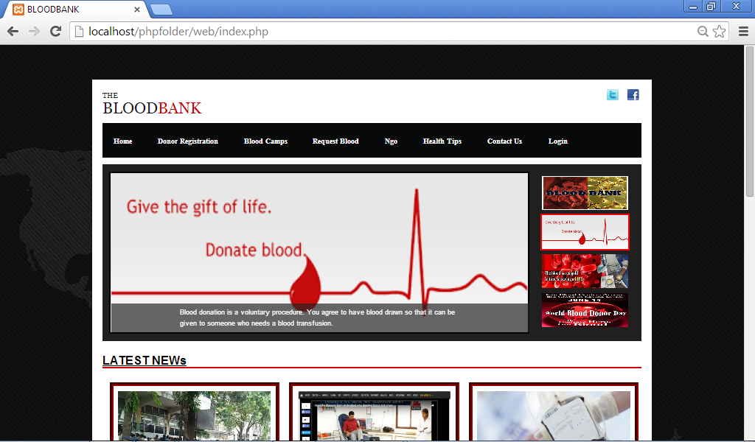

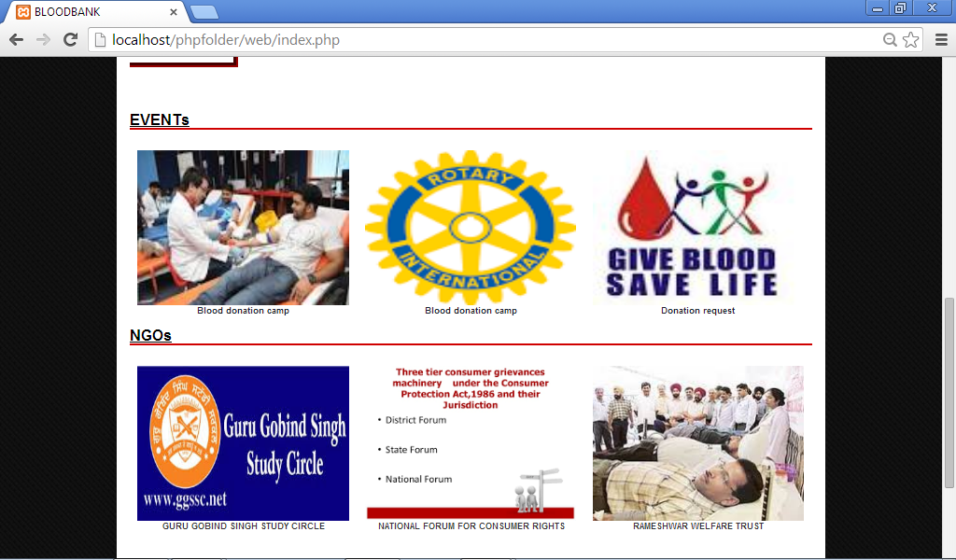

Login page

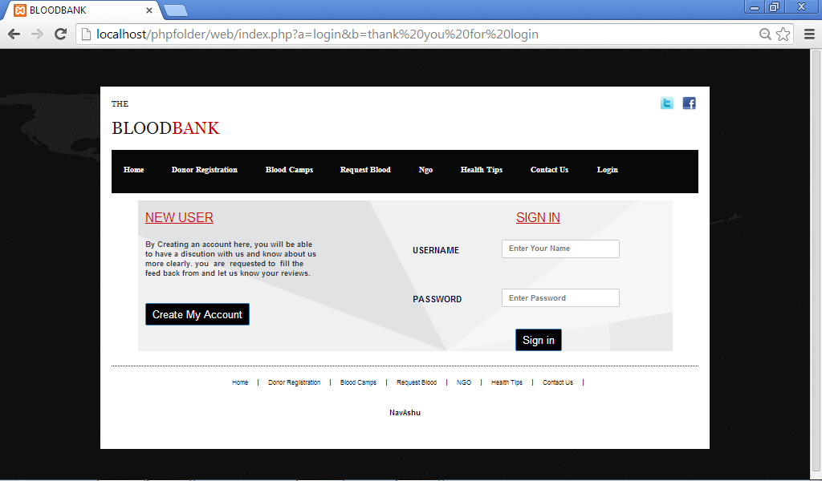

Donor registration

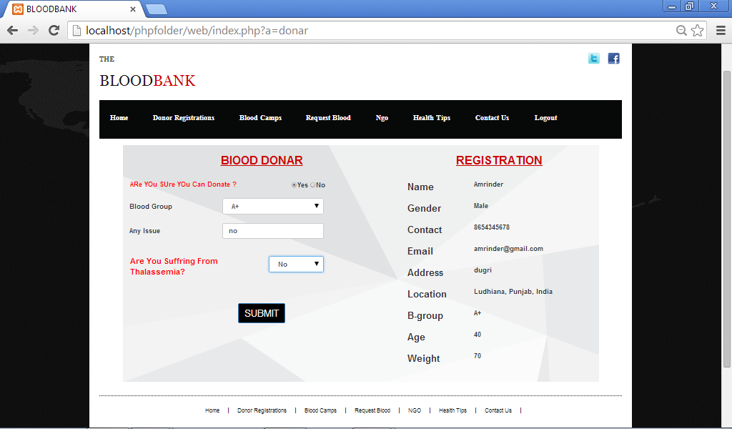

Blood camps

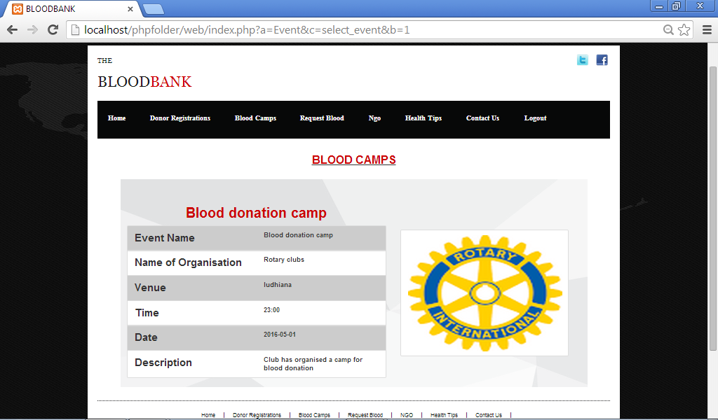
Request blood

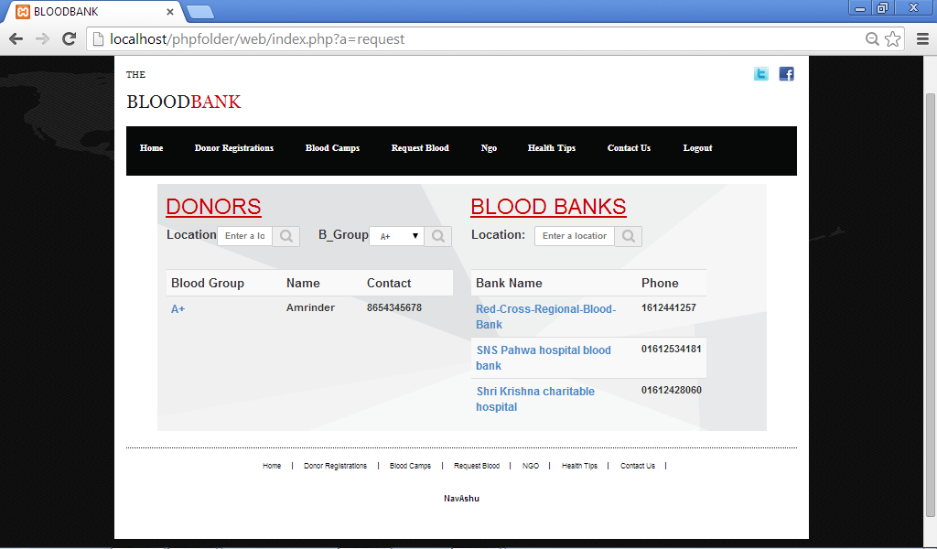

Ngo page

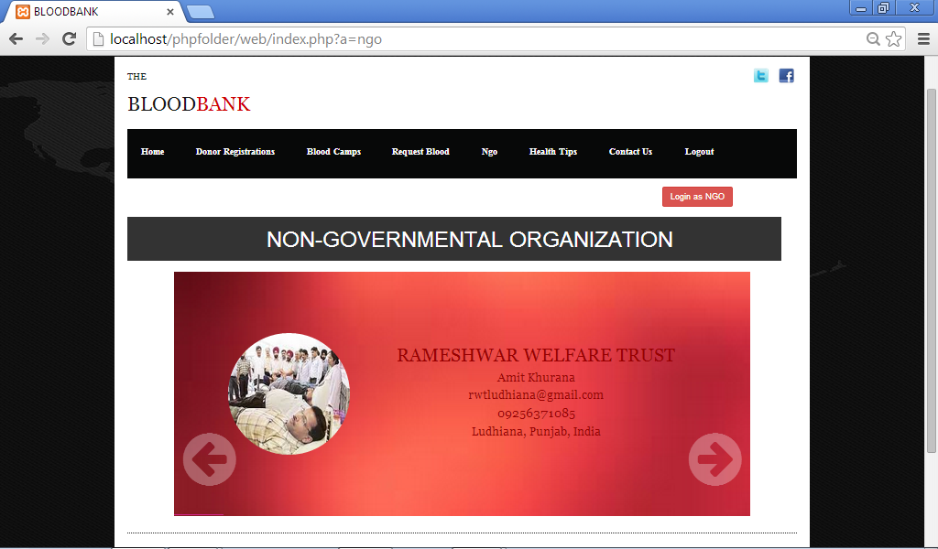

Health Tips

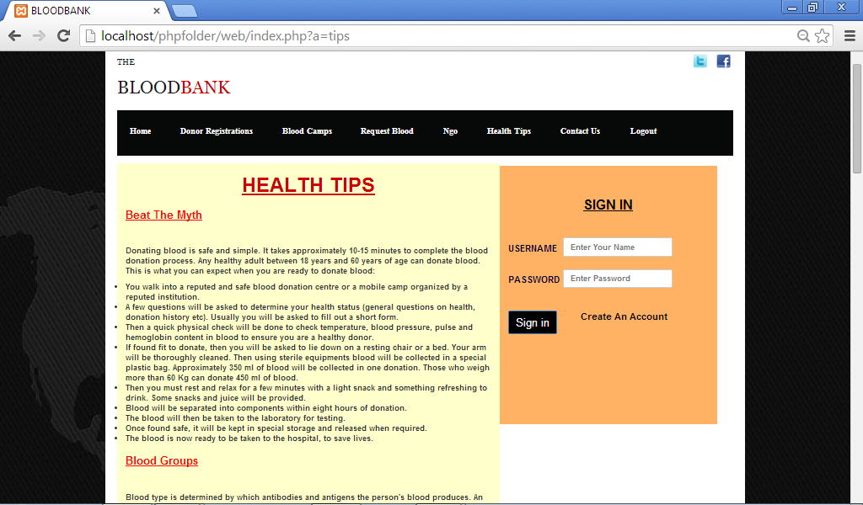

Contact page

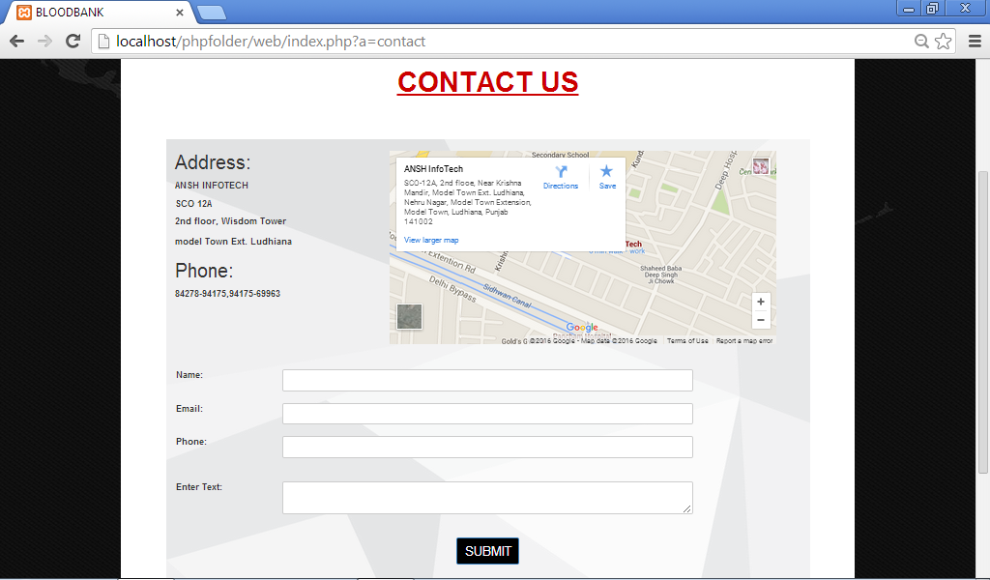

Admin panel

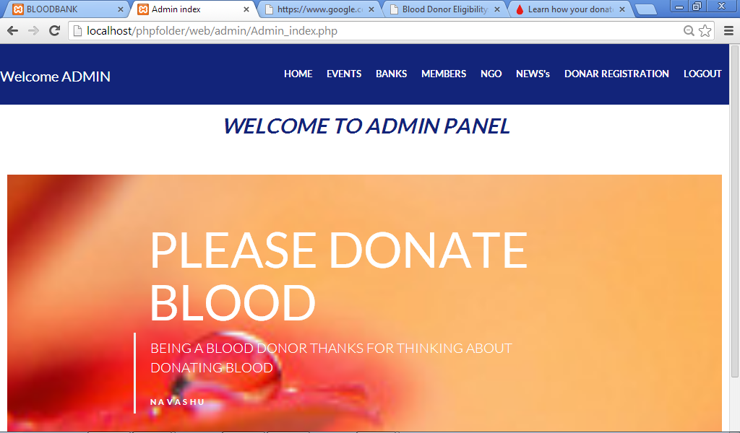

Display events

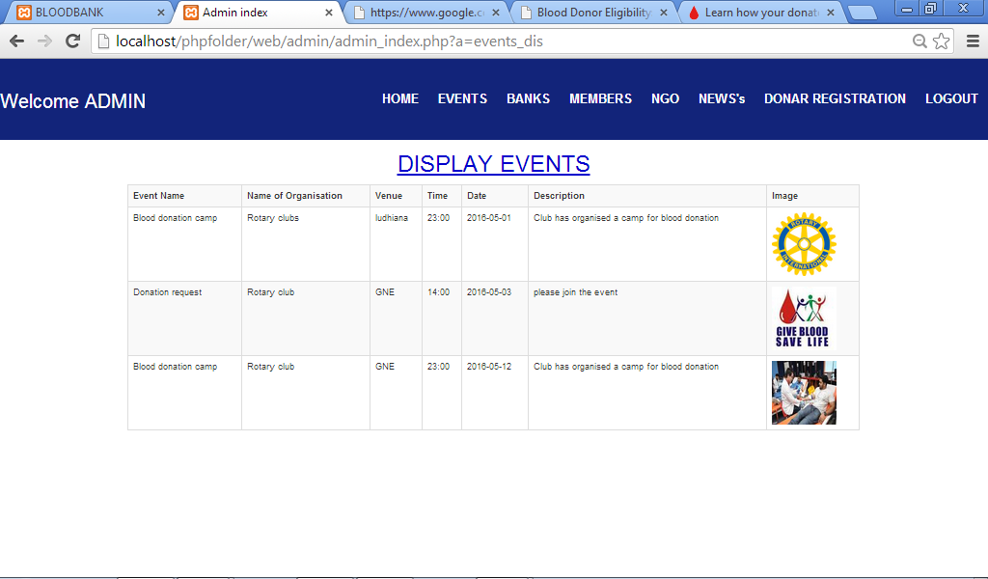

Insert bank

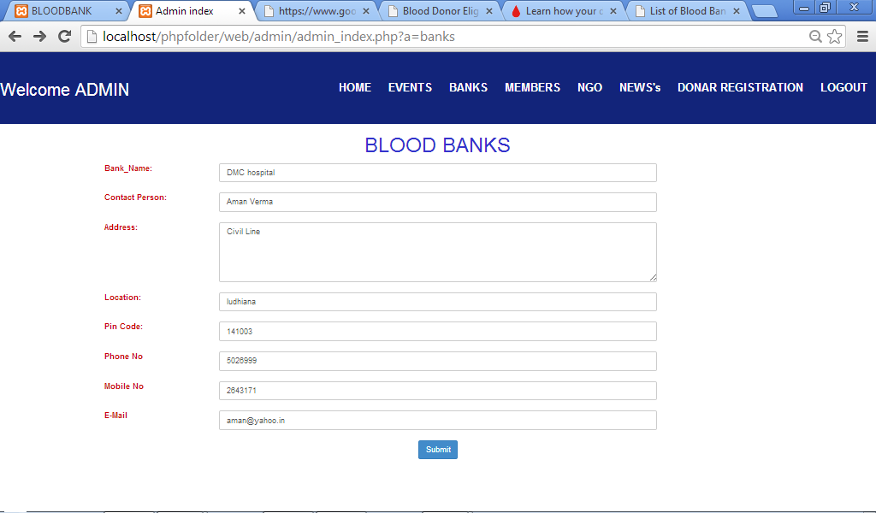

Display bank

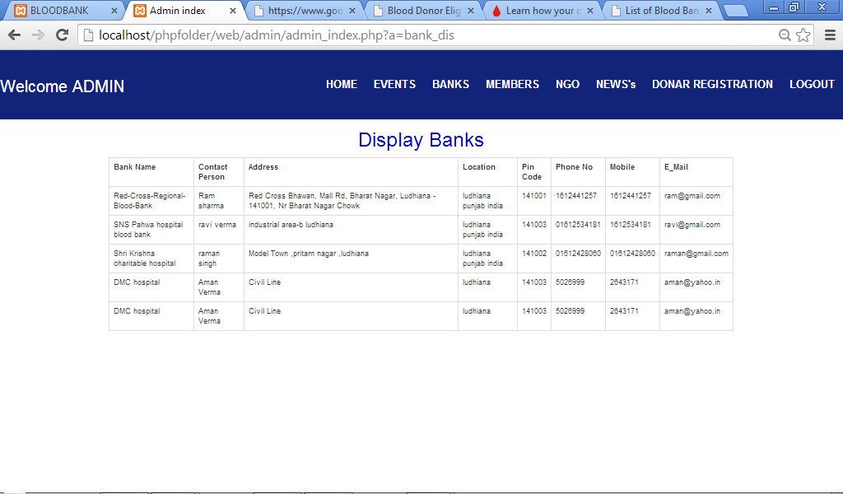

Display News

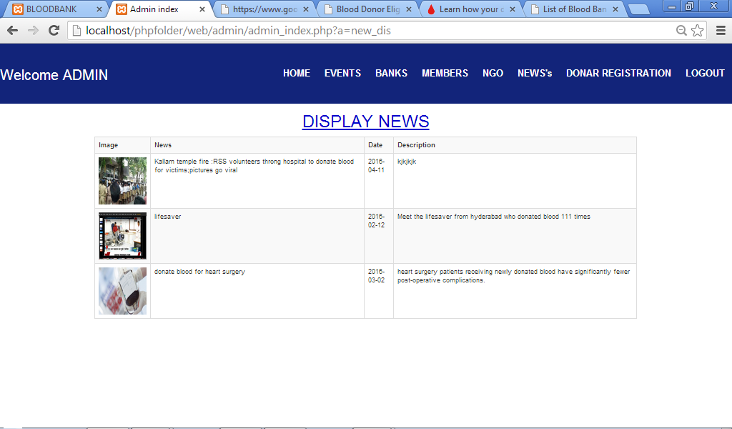

Database pages

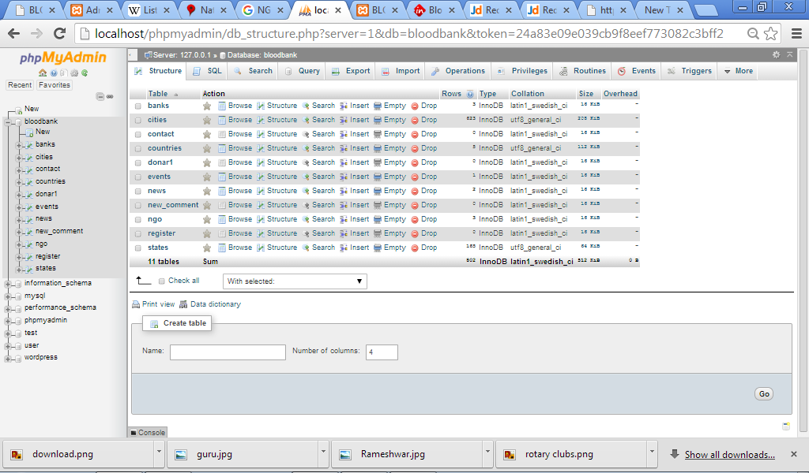

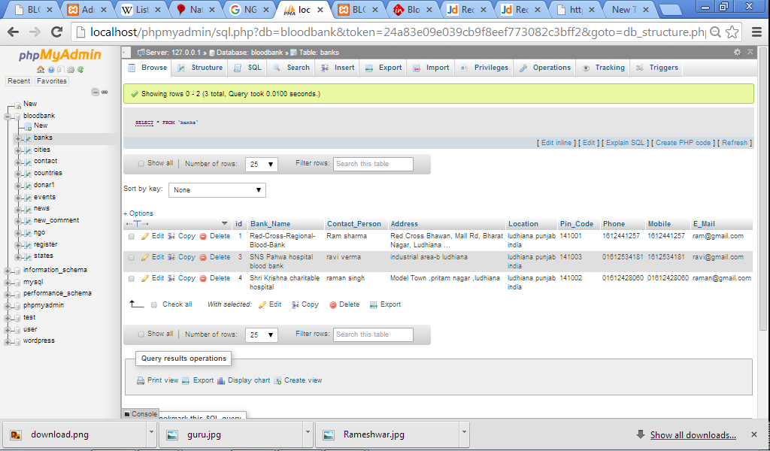

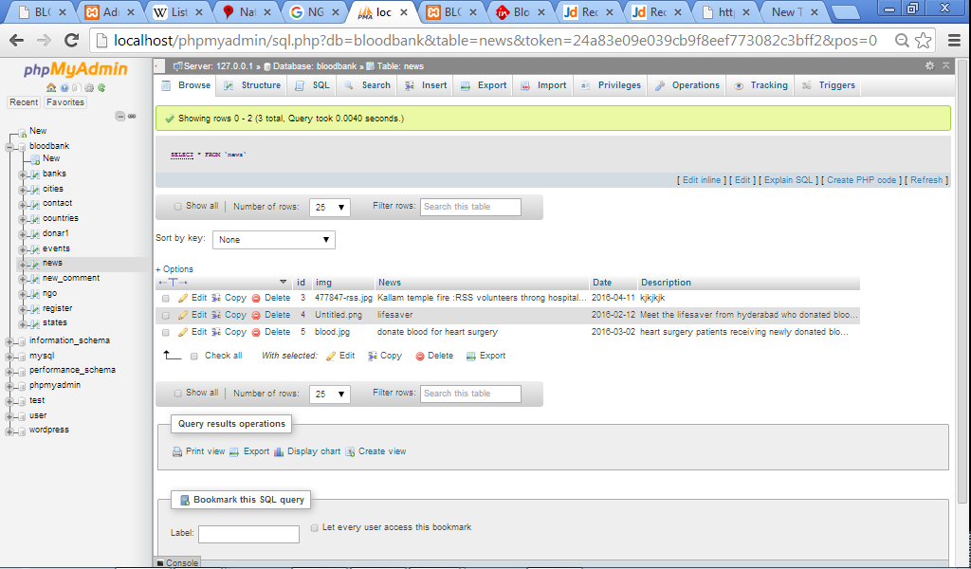

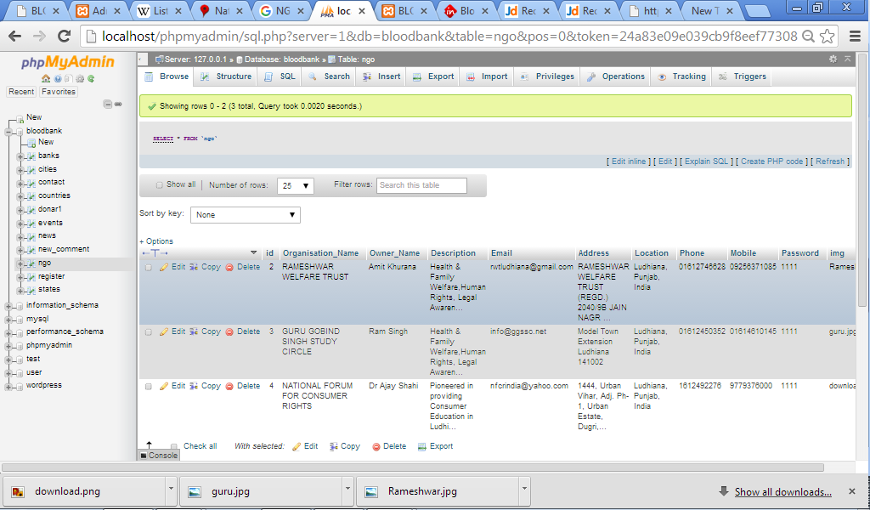

Testing

Software testing is an investigation conducted to provide stakeholders with information about the quality of the product or service under test. Software testing can also provide an objective, independent view of the software to allow the business to appreciate and understand the risks of software implementation. Test techniques include the process of executing a program or application with the intent of finding software bugs (errors or other defects).

Software testing involves the execution of a software component or system component to evaluate one or more properties of interest. In general, these properties indicate the extent to which the component or system under test:
- Meets the requirements that guided its design and development,
- Responds correctly to all kinds of inputs,
- Performs its functions within an acceptable time,
- Is sufficiently usable,
- Can be installed and run in its intended environments, and
- Achieves the general result its stake holder’s desire.

As the number of possible tests for even simple software components is practically infinite, all software testing uses some strategy to select tests that are feasible for the available time and resources. As a result, software testing typically (but not exclusively) attempts to execute a program or application with the intent of finding software bugs (errors or other defects). The job of testing is an iterative process as when one bug is fixed, it can illuminate other, deeper bugs, or can even create new ones.

Software testing can provide objective, independent information about the quality of software and risk of its failure to users and/or sponsors.

Software testing can be conducted as soon as executable software (even if partially complete) exists. The overall approach to software development often determines when and how testing is conducted. For example, in a phased process, most testing occurs after system requirements have been defined and then implemented in testable programs. In contrast, under an Agile approach, requirements, programming, and testing are often done concurrently.

Testing methods

- Static vs. dynamic testing: -There are many approaches available in software testing. Reviews, walkthroughs, or inspections are referred to as static testing, whereas actually executing programmed code with a given set of test cases is referred to as dynamic testing. Static testing is often implicit, as proofreading, plus when programming tools/text editors check source code structure or compilers (pre-compilers) check syntax and data flow as static program analysis. Dynamic testing takes place when the program itself is run. Dynamic testing may begin before the program is 100% complete in order to test particular sections of code and are applied to discrete functions or modules. Typical techniques for this are either using stubs/drivers or execution from a debugger environment.

- White-box testing: - White-box testing (also known as clear box testing, glass box testing, and transparent box testing and structural testing, by seeing the source code) tests internal structures or workings of a program, as opposed to the functionality exposed to the end-user. In white-box testing an internal perspective of the system, as well as programming skills, are used to design test cases. The tester chooses inputs to exercise paths through the code and determine the appropriate outputs. This is analogous to testing nodes in a circuit, e.g. in-circuit testing.

- Black-box testing: -Black-box testing treats the software as a "black box", examining functionality without any knowledge of internal implementation, without seeing the source code. The testers are only aware of what the software is supposed to do, not how it does it. Black-box testing methods include: equivalence partitioning, boundary value analysis, all-pairs testing, state transition tables, decision table testing, fuzz testing, model-based testing, use case testing, exploratory testing and specification-based testing.

- Grey-box testing: -Grey-box testing (American spelling: gray-box testing) involves having knowledge of internal data structures and algorithms for purposes of designing tests, while executing those tests at the user, or black-box level. The tester is not required to have full access to the software's source code. Manipulating input data and formatting output do not qualify as grey-box, because the input and output are clearly outside of the "black box" that we are calling the system under test. This distinction is particularly important when conducting integration testing between two modules of code written by two different developers, where only the interfaces are exposed for test.

Future Scope
- A chat script can be started between the donor and seeker so that the seeker can directly contact the blood donor.
- Members can have an access to directly ask queries and question to the NGO owner so that they can minimize their doctor’s visit.
- Hospitals can also link with us through new module preferring the operation similar to bank.
- Discussion can be added on every page so that every seeker can message to donor of their queries and every member can view the answers of the queries.

WEBLIOGRAPHY

- http://www. bloodconnect.org.
- http://www. centralbloodbank.org/
- http://www.bloodbankindia.com

